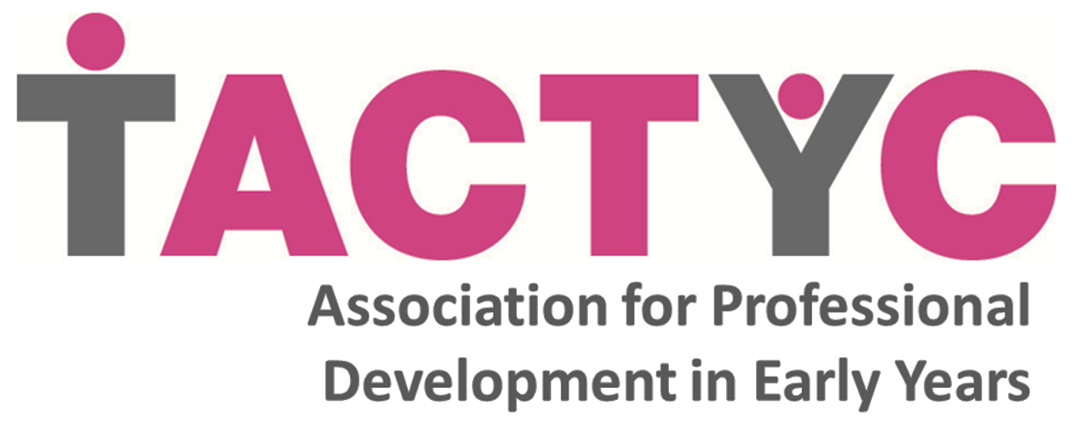

**Response to DfE consultation:**

**Literacy and numeracy qualification requirements for level 3 Early Years Educator staff November 2016**

**7. What English knowledge and skills do staff need to perform at level 3 Early Years Educator level?** (all ticked)

A range of speaking and listening skills to develop relationships with children, parents and other professionalsBeing able to communicate effectively, verbally and in writing, with parents and other professionalsBeing able to write meaningful documentation with good spelling and grammarBeing able to comprehend written materialConfidence in understanding the literacy requirements in the EYFS and how to impart them to young learners (creating and thinking critically, listening and attention, understanding, speaking, reading and writing)An appreciation of the importance of reading in supporting own development and that of young childrenAn understanding of how to experiment with and use language creativelyAbility to select/adapt speech/writing to different situations and audiencesIndependent thinking and workingOther, please explain



If you have answered 'other' please give more details here

Early Years Educators need continually to develop their professional understanding, and so beyond the ability to comprehend written material they need to be able to read critically, including reflecting on material from a variety of sources, evaluating and making links with previous concepts and their own practice.

**8. What mathematical knowledge and skills do staff need to perform at level 3 Early Years Educator level?** (all ticked)

Confidence in understanding mathematical terms and concepts relevant to the job role and how to apply them in an early years setting e.g. simple concepts such as addition, subtraction and percentages and skills required to manage a budgetAbility to present numerical information appropriately and to interpret numerical information e.g. review performance data or budget informationConfidence in understanding the numeracy requirements in the EYFS and how to impart them to young learners (numbers, space, shape and measures)Ability to identify opportunities for children to develop and improve their skills in counting, understanding and using numbers, calculating simple addition and subtraction problems; and to describe shapes, spaces, and measuresUnderstanding how to use everyday mathematical vocabulary to talk about size, weight, capacity, position, distance, time and money to compare quantities and objects and to solve problems, using mathematical language to describe themThe ability to apply mathematical knowledge successfully to different contexts including every day and real world situationsIndependent thinking and workingDeveloped problem solving skillsOther, please explain



The level of the mathematical content of the EYFS is such that practitioners with less than a GCSE qualification could potentially understand and support the mathematical development of young learners. The demands of budgeting, understanding data, and so on would require somewhat higher levels of mathematical facility, but it is important to remember that being able to do accounts and budgets is a very different matter to understanding how best to support children's mathematical thinking, which has more to do with pedagogical understanding than maths knowledge per se. It is particularly important that young children see and hear practitioners using mathematical concepts confidently and naturally, to avoid sowing the seeds of the idea that mathematics is difficult and only for those who are ‘clever’. It might be better if an alternative mathematics course at level 2, more tailored to the demands of the role of EYE, were developed by the sector.

The role of early years educator is professionally demanding, and requires a high level of ability to analyse large bodies of information in seeking to interpret, understand and support all children's individual learning, drawing on both communicative literacy and mathematical literacy. Traditionally early years work has been seen as fairly low level and undemanding intellectually. It is imperative that instead the sector attracts some of the most able learners. For this reason, we suggest that the entry level requirement should be for at least three GCSEs including English language at grade C or above, along with a specific sector-developed maths qualification. There would otherwise be a risk of returning to the situation of the least qualified staff working with the youngest children, who in fact need contact with individual staff who are not just caring but also interact with informed, keen intelligence.

**16. What qualification requirements at level 2 do you think are most appropriate for level 3 staff in English?**

**GCSE grade C or above in English**Functional Skills English Level 2No suitable qualification currently exists, developing a bespoke qualification on effective practice to engage young children in literacy learning would be most appropriate for this roleOther, please explain



If you have answered 'other' please give more details here

**17. What qualification requirements at level 2 do you think are most appropriate for level 3 staff in maths?**

GCSE grade C or above in mathsFunctional Skills maths Level 2No suitable qualification currently exists, developing a bespoke qualification on effective practice to engage young children in numeracy learning would be most appropriate for this role**Other,** please explain



If you have answered 'other' please give more details here

We endorse the Nutbrown Review’s recommendation that ‘Students must already hold level 2 qualifications in English and mathematics before they begin a level 3 early education or childcare course.’ (Nutbrown, 2012, p. 6). Ideally, GCSE maths should be the requirement as it is a recognisable, transferable standard and would be necessary for practitioners to continue to develop professionally, undertaking Level 4 courses or progressing to Early Years Teacher. Current Functional Skills qualifications should not be an alternative, as they lack the rigour of GCSEs. There has been a difficulty with a variety of supposed maths equivalency qualifications where students have embarked on courses only to find that that particular maths qualification will not be an acceptable alternative further down the line of their careers. Any alternative must be fit for purpose and relevant to the sector. If maths GCSE is not to be retained, a reasonable requirement might be for a minimum of 3 GCSEs at C or above to include English language, along with a specific sector-developed maths qualification.

**18. At what stage should the relevant literacy and numeracy qualifications be gained?**

**On entry to early years training**On entry to work in an early years settingOther e.g. after a post qualifying year while in paid employment



If you have answered 'other' please give more details here

If a sector-specific maths qualification is developed, that could be a requirement on entry to work in an early years setting, rather than on entry to training. Minimum 3 GCSEs including English language should, however, be required on entry to training.