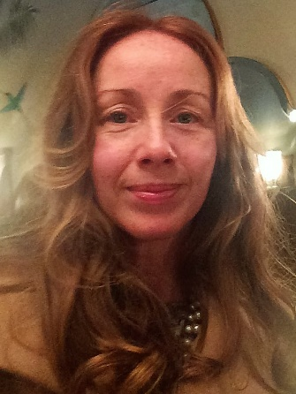
My name is VIKI VEALE. I am a senior lecturer in early years and primary education at St Mary’s university Twickenham. My aim has always been to empower others. To nurture within them a lifelong passion for learning that leads them towards achieving and exceeding in all that they desire to do.
I have had a broad and varied career in teaching working with children from reception to year six. In addition to my role as a class teacher, I have always embraced the opportunity to mentor students and newly qualified teachers as they take the first steps on their journey into teaching. I have also enjoyed the opportunity to encourage and inspire not only the children in my care, but, through the relationships I have built up with their parents, and my work as a leader for family learning, their parents and careers too.
As a senior leader, I initiated and ran training sessions to upskill teaching and learning assistants in each of the schools I worked in, helping them to develop their confidence in computing and the use of positive behaviour strategies. I also provided additional support and training for all staff in how to promote physical development, creativity and outdoor learning. As my career developed, this led me into external training provision and consultancy work.
After 15 years teaching and leading throughout the primary sector in a range of socially diverse settings, I became a parent. In order to enjoy my children’s early years, I retrained as a childminder. I soon became a childminder mentor, supporting new childminders in establishing their businesses and organising group meetings to share best practice, resources, ideas and behaviour strategies. This evolved once more into consultancy work across a new range of settings including schools, nurseries, sure start centres, play groups and home based childcare settings.
Working closely with schools, child minders, nurseries new parents and PTA’s, I led development of a transition to primary program for children and families. Expanding upon the traditional ‘stay and play session model’ this comprehensive program identified and addressed key concerns such as changing for PE, lunchtimes, toileting, routines and communication. It ensured that children started school feeling more familiar with and confident in their new environment and that new parents were able to discuss their fears and concerns with those with more experience so that they too were comfortable and confident with this transition.
I returned to teaching in 2015 before transitioning into full time lecturing in initial teacher training. This role allows me to continue to support and empower student teachers and other practitioners. It also enables me to pursue my research interests into the development of effective behaviour for learning and strategies to support transition. In 2017 I presented a briefing paper at the TACTYC conference on Birmingham on my research into the impact of digital technology on children’s behaviour and school readiness, and the continued importance of outdoor play. This paper is available on the TACTYC website.
I remain committed to encouraging those working with young children to gain qualifications and accreditation that recognise and reflect the impact that we, as practitioners have in early childhood education and development.

