Exploring residential mobility: Learning about how young children experience the transition of moving house and how adults can best support them
Elizabeth Thomas
School of Education and Childhood Studies
University of Portsmouth

Introduction
Residential mobility occurs for a variety of reasons; from an imperative need driven by poverty to the desire for a larger home due to an expanding family. The phenomenon of moving house features “high in stressful life events” (Martin, Leach, Norman, & Silvester, 2000). If this process is perceived as stressful for adults, it is likely to also be stressful for children due to the interwoven social context of family life. However, children’s personal experiences are often neglected. This study sought to draw out the voice of the child, addressing the following aims:
1) To explore how young children experience residential mobility.
2) To identify support strategies that adults can provide in order to mitigate any negative effects and maximise potential benefits of residential mobility for young children.
The context of this study
It is widely known that children often experience challenges when facing transitions of any kind during their early years (Fabian & Dunlop, 2002). The majority of research focuses on educational transitions; moving between rooms within early years settings (O’Farrelly & Hennessy, 2014) and transitioning into year 1 (Ahtola et al., 2011; LoCasale-Crouch, Mashburn, Downer, & Pianta, 2008). While these transitions are important to consider, there are many other transitions which occur within and around the family home, such as breakdown in family relationships, bereavement and residential mobility, which can sometimes have more of an impact than those within early years settings (Lee & McLanahan, 2015; Warren & Font, 2015).
The UK is currently experiencing a “broken housing market” (DCLG, 2017, p.1) with an increase in the number of families renting and an increase in the cost of housing. Landlords are legally able to restrict tenancy agreements to six months, indicating that families may sometimes have to move house as regularly as twice per year. With above average inflation on house prices, some families have been priced out of their rental properties, leading to a 37% increase in children living in council provided temporary accommodation in the past three years (BBC, 2017). While charities such as Shelter (Jefferys & Lloyd, 2017) and the Joseph Rowntree Foundation (Sheehy-skeffington & Rea, 2017) work towards positively influencing housing policy to reduce this instability, this study seeks to look in more detail at the individual experiences of young children with the intention of supporting children experiencing this particular transition of residential mobility.
Previous studies have found that residential mobility can have a negative impact on children in a number of ways; to their cognitive development (Hutchings et al., 2013), their emotional and behavioural development (Flouri, Mavroveli, & Midouhas, 2013) and to their physical and mental health (Coley, Lynch, & Kull, 2015). Although the majority of these and other studies show an increasing risk of negative impact with age (Bramson et al., 2016), a study by Rumbold et al (2012) shows that house moves in the earliest years are the most problematic. They argue that this may be due to young children's inability to fully communicate or understand what is happening. However, these studies all utilised quantitative data from large cohorts, omitting children’s perspectives entirely. It is these perspectives which may add to our understanding of how children experience their worlds and enable more effective design of support strategies for adults to provide during these challenging times of transition.
This briefing will discuss three case studies, carried out with an ethnographic approach with families moving house with young children aged 2-3 years in April 2017. A bioecological framework (Bronfenbrenner & Evans, 2000) is used to structure the discussion. The discussion and conclusion will include suggestions for support strategies emerging from the data which may be helpful for future house moves and other similar transitions.
Methods
This study took a constructionist approach, which frames participants as social actors within a socially constructed context (Bryman, 2008). In attempting to learn how children experience a phenomenon such as residential mobility, their perspective of the social aspect of their own lived experience was important to consider.
As a brief introduction to the three case studies to provide a context for these findings, the following table shows an outline of the characteristics and context of each case child.
 | Speedy | Ariel | Bing
Child’s age | 3 years | 3 years | 2 years
Child’s gender | Male | Female | Female
Child’s personality | Sensitive; sensible | Very shy; emotional | Extrovert; happy; playful
Family situation  () = lives elsewhere | Mum - Sophie  Dad - Sam  1yr old sister - Summer | Mum – Anna  6yr old brother – Adam  (Dad – Ash) | Mum - Becca  Dad - Ben
Reasons for move | Previous flooding; first-time buyers | Priced out of rental property | Temporary rental; first-time buyers
Location change | Moved ten minutes away from original location | Moved 40 minutes away from original location | Moved down the road, less than 1 minute away
Additional stressors | Dad working away frequently; sister ill | Mum does not drive; difficulty securing local school places | Only moved 8 months prior to this move
Support structures | Family; church | Grandparents; friends | Church – no family locally
Table 1: Case study overview
Each child was allocated the same number of hours from a week prior to the house move until three months after the move. The visits were spread out to gain a perspective of how the child’s experience changed over time.
Mixed methods were used for data collection. These included participant observations with doll’s house role play, reading fiction and non-fiction stories about house moves and giving children the opportunity to take photographs and create drawings which they could then discuss. Alongside these child-centred methods, unstructured interviews were carried out with parents and carers to gain further context for the child’s contributions.
Analysis was carried out with the aid of CADQAS, specifically Nvivo 11, using a bioecological framework (Bronfenbrenner & Evans, 2000). The bioecological framework is divided into four categories. The first of these categories is termed ‘context’; this required identifying the reasons for residential mobility and exploring a variety of case studies of young children experiencing residential mobility, which provided a good comparison against context variables. The second is ‘proximal processes’. Analysing the child’s proximal processes required observing interactions of the child with family members, peers and caregivers and analysing how these interactions influenced the child. Within the proximal processes, attachment theory was also considered (Bowlby, 1982) as a way of understanding the child’s relationships with those around them. Thirdly, ‘person characteristics’; the study sought to discover who the child is – their interests, the ways in which they communicate, their position in the family and how this impacted upon their response to residential mobility. Finally, the aspect of ‘time’; considering the longitudinal aspect of the study. It was expected that the child would have a varied experience before and after the move and that their experience would continue to change over time; therefore, time was an important aspect to consider.
Findings and discussion
Context
Despite similarities between cases, each case child had very different experiences due to their familial, social and environmental contexts. A large bulk of the literature suggests that the reasons why families move may be one of the biggest factors in children’s outcomes (Bramson et al., 2016; Coley & Kull, 2016; Hango, 2006; Morris, Manley, Northstone, & Sabel, 2016; Pettit, 2004; Root & Humphrey, 2014; Roy, McCoy, & Raver, 2014; Schmitt, Finders, & McClelland, 2014); however, as explored in this discussion, this is only one part of a huge bioecological context contributing to the children’s experiences.
Bing and Speedy’s families were both moving because they were able to purchase a house for the first time. Their moves were short distances and gave them the opportunity to maintain all other aspects of their lives including their support networks, changing only their home. This enabled them to settle in to their new homes with familiar people around them. Ariel’s family had a different situation which presented many challenges. Their six-monthly tenancy agreement was coming to an end and the landlord had agreed to extend for a further six months, but with an increase in rent and a re-signing fee. Anna was unable to afford the extra expenses and was offered the new property by an extended family member as a cheaper option. However, this new property was a forty-minute drive away from their previous home and Anna was not yet able to drive, although she was having lessons. Support networks are a protective factor in the development of resilience (Lucier-Greer et al., 2015), including “healthy social connections” (p.363), some of which Ariel lost in the process of residential mobility. Despite the best intentions of friends and extended family members, the distance the family moved impacted upon people’s ability to provide support. Ariel struggled with this aspect of the house move and became more emotional and reliant upon her Mum as a result.
Due to the multi-faceted nature of residential mobility, there can be no one conclusion here. However, it seems that with Bing and Speedy having their support networks maintained, this supported their resilience. This would suggest that if families are intending to move house a distance from their current home, a recommendation might be to seek out a faith or interest group in the new locality in order to create a new support network prior to the move.
Proximal processes
One of the most frequently discussed issues in the literature is how parental processes influence children’s experiences (Anderson et al., 2014; Riina, Lippert, & Brooks-Gunn, 2016; Steele et al., 2016). This originates predominantly from the ‘Family Stress model’ (Masarik & Conger, 2017) which is used to argue that parental stress during a house move may cause “inconsistent, unsupportive, harsh and punitive parenting behaviour” (Leventhal & Newman, 2010, p.1167) which may be associated with any negative effects on the child following the house move.
Throughout two of the case studies, Ariel and Speedy, I saw or heard of moments where stress had overcome parents and caused them to find parenting challenging. For example, Anna, who is a single parent and had to deal with the stressors of moving house with two children. Speedy’s parents also experienced stress on moving day because Sophie had been so relaxed leading up to the move, and being left to arrange their belongings in the new house was an unexpected occurrence. Although these were the stories parents felt they wanted to share, when I was in their homes I witnessed many moments of positive and supportive parenting which I believe far outweighed the challenging, stressful moments. Parents all had positive interactions with their children and responded well to their children’s extreme emotions that arose from the instability of the move. Ariel was the only child who alluded to parental stress herself when we were reading a story prior to their move. Speedy had very clear and secure attachments to his family members, both nuclear and extended. When he took photos around the house, he insisted upon picturing his Mum and Summer on several occasions.
Despite the children’s apparent indifference to their parents’ stressful moments, however, it was clear that parents themselves felt stressed and it bothered them that they had displayed this stress in front of their children. In light of this, it could be recommended that exercises be carried out to reduce parental stress; for example, spending time together as a family and putting the packing to one side for a set amount of time.
Person characteristics
Bronfenbrenner and Evans (2000) argue that proximal processes are a result of a combination of the environmental context and “the characteristics of the developing person” (p.118). This development of a child’s personality progresses with maturity from one of dependence to one of being agentic (Bandura, 2006). There was evidence within the data of children’s personalities, both their dependency and agency, affecting the shape of their experiences.
Ariel was very quiet and shy. During all of the research visits, she did engage but with limited verbal communication. Because there were a variety of methods used in this study, Ariel’s lack of verbal communication did not distract from the story she was able to tell through her expressions, photographs, drawings and utterances. Bing, however, was very bubbly and boisterous. Her personality led her to have emotional outbursts at times, even before the stresses of residential mobility became apparent. The day before the move, when Bing arrived home to her house packed up in boxes, she found it overwhelming and needed comfort from Becca. Speedy was a deep thinker; emotional and thoughtful. He did not seem to have attachments to possessions or particular toys; his photos were mostly of locations and people.
The understandings the children had of what residential mobility is were different. The doll’s house role play activity and reading stories were designed to enable me to have an insight into how the children thought the process might work alongside supporting that understanding prior to the move. During the doll’s house role play, Ariel moved one of the houses by picking it up and walking it to another place in the room. It may have been because it was a toy house with a handle on top, or it may have been because Ariel thought she could actually relocate a building. Reading the stories, she had a limited understanding of what packing entailed, explaining that once things were in boxes, they were gone. Bing also showed that she struggled to understand what would happen when she moved house through the activities we engaged in together and through her extreme reactions to the process of moving.
This may be linked to their age and stage of development; according to Piagetian theory (cited in Conkbayir, 2017), when young children are faced with new information this causes their brain to go into a state of “disequilibrium” until the brain has modified its existing neural pathways to assimilate this information (p.15). The more often this happens, the easier children find it to take in new information. It may be that Ariel and Bing were still going through the early processes of information assimilation.
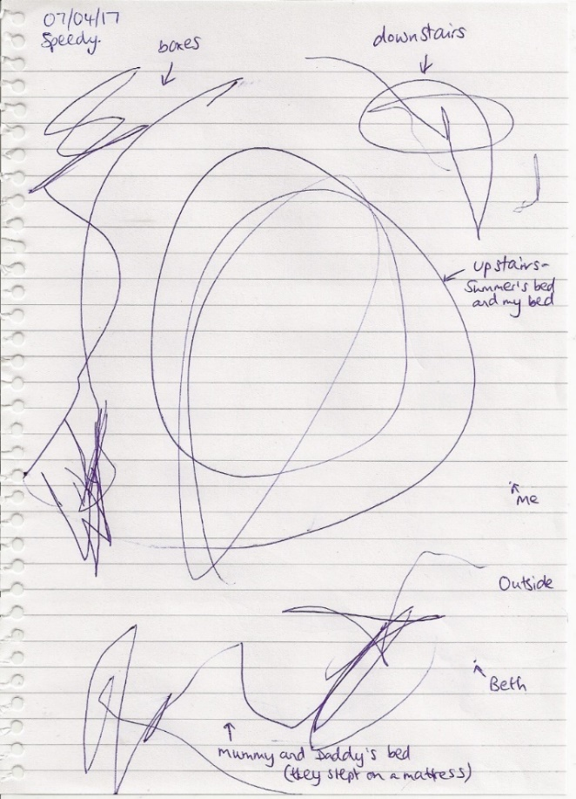
Speedy, however, being almost four years old, had a clearer understanding of what was going to happen. He drew several pictures which all represented reality; his picture of the new house was perceptibly honest, with the inclusion of the fact that Mummy and Daddy had slept on a mattress on the first night in their new house.

Figure 1: Speedy's drawing of the new house
These findings show that the children’s abilities to understand what was happening differed and it seemed to be their age which was the key factor in shaping this. Mathers et al (2014) argue that children telling personal stories of events which have affected them emotionally help to develop “their sense of self, their self-regulation and understanding of others’ minds.” (p.11). This suggests that providing them with their own stories to tell others may be helpful, alongside using age-appropriate ways of communicating the process of a house move such as role play games.
Time
Aside from the axiomatic change of property and those stressors previously discussed, each child also communicated the material stability and changes over time that were significant to them. I was able to identify these with the use of photography as the children took pictures of their most important items in their houses. Those things which remained constant gave the children a sense of continuity while they settled in to their new homes (Kagan, 1971).
Ariel’s distinct change between the old and new houses was that she went from having a bath to a shower. On my first visit to the new home, the shower was the first thing Ariel showed me and she was keen to take a photograph of it.
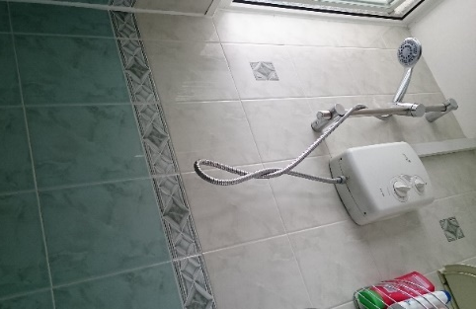
Figure 2: Ariel's bath in old home
Figure 3: Ariel's shower in new home
The most significant item of stability over time that was prominent in the data was Speedy’s box house. In the week leading up to the move, Speedy had a cardboard box which he covered in a blanket and played in. When he had moved, Speedy recreated the box house including the draped blankets on several occasions.
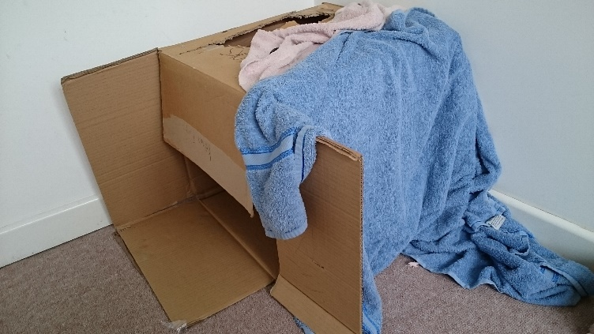
Figure 4: Speedy's box house
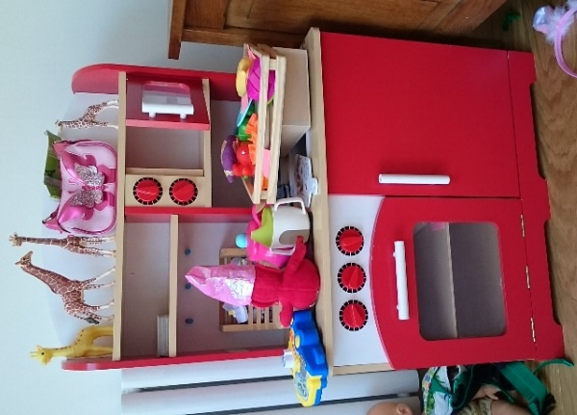
Bing had one stable item which she played with at every visit and clearly lamented over when the house had been packed up ready for the move; her play kitchen.
Figure 5: Bing's play kitchen
It appears that the constancy of resources provided a stability and ‘safe place’ for the children to be able to play, with their own toys they felt comfortable with. This would suggest that selecting specific favourite items for immediate access in a new home might be important to consider.
Conclusion
The intention of this research was to explore how young children experience residential mobility and how transitional practices with young children might apply to residential mobility. According to the data, all children’s experiences are different; therefore, there cannot be a ‘one-size-fits-all’ approach to supporting families who are moving house. However, it seems that young children experience short-term anxiety from misunderstandings of residential mobility that would concur with the literature, although it is not clear from this data if these effects would continue to have an impact on children later in life. The recommendations drawn out of the findings combine regular transitional practices with the specific transition of moving house which are:
- seeking out faith or interest support groups prior to a house move
- carrying out exercises to reduce parental stress such as family time together
- using age-appropriate ways of communicating the process of the house move with the child such as reading stories or playing role play games
- enabling access to favourite toys or comfort items immediately in a new home.
If these support strategies are implemented with young children experiencing residential mobility, there is potential to reduce the instances of lasting negative effects shown in the previous literature.
Future research should engage in a larger sample of cases of both planned and unplanned house moves, for example, families who have been displaced to temporary accommodation or refugee situations, to identify similarities and differences between cases. The implementation of the support strategies suggested above could be analysed in a variety of cases to explore how the strategies might apply in both planned and unplanned cases.
References
Ahtola, A., Silinskas, G., Poikonen, P. L., Kontoniemi, M., Niemi, P., & Nurmi, J. E. (2011). Transition to formal schooling: Do transition practices matter for academic performance? Early Childhood Research Quarterly, 26(3), 295–302. http://doi.org/10.1016/j.ecresq.2010.12.002
Anderson, S., Newman, S., Dupéré, V., Leventhal, T., Newman, S., & Dupéré, V. (2014). Residential Mobility Among Children: A Framework for Child and Family Policy. Cityscape, 16(1), 5–36.
Bandura, A. (1997). Self efficacy: The exercise of control. New York: W. H. Freeman and Company.
Bandura, A. (2006). Toward a Psychology of Human Agency. Perspective on Psychological Science, 1(2), 164–180. http://doi.org/150.131.73.116
BBC. (2017). Children in temporary housing up a third since 2014 - BBC News. Retrieved from http://www.bbc.co.uk/news/education-40685901
Bowlby, J. (1982). Attachment. New York: Basic Books.
Bramson, L. M., Rickert, M. E., Class, Q. A., Sariaslan, A., Almqvist, C., Larsson, H., … D’Onofrio, B. M. (2016). The association between childhood relocations and subsequent risk of suicide attempt, psychiatric problems, and low academic achievement. Psychological Medicine, 46(5), 969–79. http://doi.org/10.1017/S0033291715002469
Bronfenbrenner, U., & Evans, G. W. (2000). Developmental science in the 21st century: Emerging questions, theoretical models, research designs and empirical findings. Social Development, 9(1), 115–125. http://doi.org/10.1111/1467-9507.00114
Bryman, A. (2008). Social Research Methods. Social Research (Vol. 3rd). http://doi.org/10.4135/9781849209939
Coley, R. L., & Kull, M. (2016). Cumulative, Timing-Specific, and Interactive Models of Residential Mobility and Children’s Cognitive and Psychosocial Skills. Child Development, 87(4), 1204–1220. http://doi.org/10.1111/cdev.12535
Coley, R. L., Lynch, A. D., & Kull, M. (2015). Early exposure to environmental chaos and children’s physical and mental health. Early Childhood Research Quarterly, 32, 94–104. http://doi.org/10.1016/j.ecresq.2015.03.001
Conkbayir, M. (2017). Early childhood and neuroscience: theory, research and implications for practice. London: Bloomsbury.
DCLG (Department for Communities and Local Government). (2017). Fixing our broken housing market. London. Retrieved from https://www.gov.uk/government/uploads/system/uploads/attachment_data/file/590464/Fixing_our_broken_housing_market_-_print_ready_version.pdf
Fabian, H., & Dunlop, A.-W. (2002). Transitions in the Early Years. London: RoutledgeFalmer.
Flouri, E., Mavroveli, S., & Midouhas, E. (2013). Residential mobility, neighbourhood deprivation and children’s behaviour in the UK. Health & Place, 20, 25–31. http://doi.org/10.1016/j.healthplace.2012.12.002
Hango, D. (2006). The Long-Term Effect of Childhood Residential Mobility on Educational Attainment. The Sociological Quarterly, 47(4), 631–664. http://doi.org/10.1111/j.1533-8525.2006.00061.x
Hutchings, H. a, Evans, A., Barnes, P., Demmler, J., Heaven, M., Hyatt, M. a, … Dunstan, F. (2013). Do children who move home and school frequently have poorer educational outcomes in their early years at school? An anonymised cohort study. PloS One, 8(8), e70601. http://doi.org/10.1371/journal.pone.0070601
Jefferys, P., & Lloyd, T. (2017). New civic housebuilding 2017: Rediscovering our tradition of buidling beautiful and affordable homes - Policy briefing. Retrieved from https://civichousebuilding.org/wp-content/uploads/2017/03/NCH_Policy_Report.pdf
Kagan, J. (1971). Change and continuity in infancy. New York: Wiley.
Lee, D., & McLanahan, S. (2015). Family Structure Transitions and Child Development: Instability, Selection, and Population Heterogeneity. American Sociological Review, 0003122415592129-. http://doi.org/10.1177/0003122415592129
Leventhal, T., & Newman, S. (2010). Housing and child development. Children and Youth Services Review, 32(9), 1165–1174. http://doi.org/10.1016/j.childyouth.2010.03.008
LoCasale-Crouch, J., Mashburn, A. J., Downer, J. T., & Pianta, R. C. (2008). Pre-kindergarten teachers’ use of transition practices and children’s adjustment to kindergarten. Early Childhood Research Quarterly, 23(1), 124–139. http://doi.org/10.1016/j.ecresq.2007.06.001
Lucier-Greer, M., Arnold, A. L., Mancini, J. A., Ford, J. L., & Bryant, C. M. (2015). Influences of Cumulative Risk and Protective Factors on the Adjustment of Adolescents in Military Families. Family Relations, 64(3), 363–377. http://doi.org/10.1111/fare.12123
Martin, R., Leach, D., Norman, P., & Silvester, J. (2000). The role of attributions in psychological reactions to job relocation. Work & Stress, 14(4), 347–361. http://doi.org/10.1080/02678370010029186
Masarik, A. S., & Conger, R. D. (2017). Stress and child development: A review of the Family Stress Model. Current Opinion in Psychology, 13(June), 85–90. http://doi.org/10.1016/j.copsyc.2016.05.008
Mathers, S., Eisenstadt, N., Sylva, K., Soukakou, E., & Ereky-Stevens, K. (2014). A Review of the Research Evidence on Quality of Early Childhood Education and Care for Children Under Three. Implications for Policy and Practice.
Morris, T., Manley, D., Northstone, K., & Sabel, C. (2016). On the move: Exploring the impact of residential mobility on cannabis use. Social Science and Medicine, 168, 239–248. http://doi.org/10.1016/j.socscimed.2016.04.036
O’Farrelly, C., & Hennessy, E. (2014). Watching transitions unfold: a mixed-method study of transitions within early childhood care and education settings. Early Years, 34(4), 329–347. http://doi.org/10.1080/09575146.2014.968838
Pettit, B. (2004). Moving and children’s social connections: Neighborhood context and the consequences of moving for low-income families. Sociological Forum, 19(2), 285–311. http://doi.org/10.1023/B:SOFO.0000031983.93817.ff
Riina, E. M., Lippert, A., & Brooks-Gunn, J. (2016). Residential Instability, Family Support, and Parent–Child Relationships Among Ethnically Diverse Urban Families. Journal of Marriage and Family, 78(4), 855–870. http://doi.org/10.1111/jomf.12317
Root, E. D., & Humphrey, J. (2014). The impact of childhood mobility on exposure to neighborhood socioeconomic context over time. American Journal of Public Health, 104(1), 80–82. http://doi.org/10.2105/AJPH.2013.301467
Roy, A., McCoy, D. C., & Raver, C. C. (2014). Instability versus quality: Residential mobility, neighborhood poverty, and children’s self-regulation. Developmental Psychology, 50(7), 1891–1896. http://doi.org/10.1037/a0036984
Rumbold, A., Giles, L., Whitrow, M., Steele, E., Davies, C., Davies, M. J., & Moore, V. (2012). The effects of house moves during early childhood on child mental health at age 9 years. BMC Public Health, 12(1), 583. http://doi.org/10.1186/1471-2458-12-583
Schmitt, S., Finders, J., & McClelland, M. (2014). Residential Mobility, Inhibitory Control, and Academic Achievement in Preschool. Early Education and Development, 26(2), 189–208. http://doi.org/10.1080/10409289.2015.975033
Sheehy-skeffington, J., & Rea, J. (2017). How poverty affects people’s decision-making processes. Retrieved from https://www.jrf.org.uk/report/how-poverty-affects-peoples-decision-making-processes
Steele, H., Bate, J., Steele, M., Dube, S. R., Danskin, K., Knafo, H., … Murphy, A. (2016). Adverse Childhood Experiences, Poverty, and Parenting Stress. Canadian Journal of Behavioral Science, 48(1), 32–38. http://doi.org/10.1037/cbs0000034
Thomas, E. (2017) Moving house research. Retrieved from www.movinghouseresearch.co.uk
Warren, E. J., & Font, S. A. (2015). Housing insecurity, maternal stress, and child maltreatment: An application of the family stress model. Social Service Review, 89(1), 9–39. http://doi.org/10.1086/680043

