The role of the graduate pedagogical leader in England with children from birth to thirty months

Dr Mary E. Whalley, independent consultant early childhood
(formerly at Leeds Beckett University)

Research Briefing - TACTYC Annual Conference
Conference theme: Early Childhood Professionals for 21st Century, Saturday 4 November 2017

Introduction and policy context
The past two decades or so have seen significant global focus on the breadth of early childhood education and care (ECEC) and there is now wide recognition that the impact of foundations laid down in children’s earliest years impact on children’s later life chances (Sylva et al, 2004; McDowall Clark and Murray, 2012). In England, the development of a graduate role in the ECEC workforce – for private, voluntary and independent (PVI) settings for children from birth to five - has been a significant policy issue since 1997. Initially, the Government introduced the role of Senior Practitioner, achieved through the attainment of an Early Years Sector Endorsed Foundation Degree (Department for Education and Skills, 2001) but this role was never fully established (Miller, 2008) and a new role was introduced from 2006 (Children’s Workforce Development Council (CWDC), 2006), which required graduate leaders to attain a Bachelor’s degree and meet a new set of graduate level standards which led to Early Years Professional Status (EYPS) (CWDC, 2008).

The field work for this research took place from 2013-15 and the participants all had EYPS. During the period of the study, EYPS was replaced with a new status, a new graduate pathway and set of Standards: Early Years Teacher Status (EYTS) (National College for Teaching and Leadership (NCTL), 2013). Chalke (2015) argued persuasively that EYPS had insufficient time to be established in the ECEC workforce before being replaced by EYTS. Nonetheless, by 2013, there were over 11,000 EYPs (Department for Education, 2013) – many who continue in leadership roles. In any case, I aver that the findings of this study have generic relevance to both the EYP and EYT roles.

A number of studies have been conducted to evaluate the impact of EYPS (including Foundation for Educational Research (NFER)/CWDC, 2009; Hadfield et al., 2011, 2012) and it was the findings from a major evaluation of the Graduate Leader Fund 2007-2011 – which provided around £600m to professionalise the PVI workforce through the EYP pathways – by Mathers et al. (2011) which was the spur for this research. The findings of this study highlighted many positive aspects to graduate leadership, especially in terms of the ‘added value’ that the EYP was bringing to the overall quality in Early Years Foundation Stage (EYFS) provision. However, the study found that 91% of the EYP participants were working primarily with three- and four-year olds. There was significantly less evidence of EYPs being deployed to work with the youngest children, from birth to thirty months (Bt30m). This may – in part – be explained by the legacy of the historic divide between ‘education’ for three- and four-year olds and ‘childcare’ for under-threes has resulted in the latter being viewed as of lower status (Oberhuemer, 2008). However, the graduate role was always promoted as being one of leadership of the EYFS, with children from birth to five. My study builds on Mathers et al.’s recommendation for further research on graduate leadership with children Bt30m.

Theoretical framing
The focus of the study is ‘pedagogical leadership’, which was always a defining aspect of the EYP role (CWDC, 2006). This is distinctively different to leadership or management of a setting though the terms ‘leadership’ and ‘management’ are often used interchangeably – particularly in the context of ECEC practice. This can be both unhelpful and confusing. Law and Glover (2000) offer helpful definitions of the differences between the two roles and, expressed succinctly, managers are responsible for maintenance and oversight and leaders for enhancement and development. Of course, in many ECEC settings, the one ‘in charge’ will combine both roles and have both managerial and leadership responsibilities. Indeed, Rodd (2013, p. 19) argues that leadership and management are ‘inherently linked and interwoven’.

The concept of the EYP, however, was that of pedagogical leader and introduced a new paradigm to the ECEC workforce. McDowall Clark and Murray (2012) posited the notion of ‘leadership within’ as a reconceptualization of ECEC leadership which could be applied to the graduate leader role. This is an inner knowledge and confidence in the early childhood’s practitioner capacity to lead, whether or not in a nominated leadership position. Leadership within is non-hierarchical and locates leadership as a process of three inter-connected strands. Catalytic agency involves leaders in intentionally effecting changes to practice by their involvement within it. This embraces reflective integrity where leaders can challenge themselves and others in order to bring about improvements to practice. In this, everyone is capable of contributing to leadership in early childhood settings, thus making relational interdependence a core component.

For the purposes of this study, ‘pedagogy’ here takes into account the child from infancy to toddlers (Bt30m), ‘from the newborn’s need to learn about objects to the toddlers forging of self’ (Fernyhough, 2000, preface). Such a view of Bt30m pedagogy refutes the historic notion that work with very young children was about ‘minding’ them but, rather, supports Powell and Goouch’s notion of ‘mindful care’ (2012, p.5) and draws on Rockel’s (2009) pioneering work on establishing a pedagogy of care in work with children Bt30m. This includes the care practices of feeding, nappy-changing and sleep alongside practice and provision which allows the young child to be ‘a co-constructor of knowledge, identity and culture’ (Dahlberg, Moss and Pence, 2013, p.51). Such a pedagogy takes a socio-cultural perspective of young children, taking into account all that babies and toddlers are engaged in and views effective relationships as central to how they learn and develop (Degotardi and Pearson, 2014).

Research design and methodology
The data for this qualitative research study was drawn from a small-scale collective case study (Creswell, 2013), which provided different perspectives on pedagogical leadership with children Bt30m. Although not a true ethnographic study, I wanted to explore the lived experiences of the EYP graduate leaders by gathering the data from meetings with them in their own settings, entering into their ‘worlds’. Having no direct professional experience of work with such young children, my aim was to engage in genuine inquiry and learn from them how they experienced and understood their roles. My research questions were:
- How do graduate leaders of pedagogical practice with children from birth to thirty months articulate their experiences and understanding of their leadership roles?
- What can be learned from them about the key characteristics of leading pedagogical practice with children from birth to thirty months?

The research was carried out with ethical approval from Leeds Beckett University and adhering to the guidelines from the British Educational Research Association (BERA) (2011). Given that data was to be collected from a range of visits to the EYPs’ settings, there were geographical constraints but I believe these only explain in part the struggle to identify participants. The findings of the Mathers et al. (2011) study appeared to apply here: that there are few graduate leaders working with babies and toddlers. After a protracted search – a variation on snowball sampling (Cohen and Manion, 2011) – I was able to identify six EYPs with whom I was able to work for the duration of the study, visiting each on three separate occasions over a period of 12-14 months.

I adopted a multi-method approach for the collection of data on the grounds that this not only offered a form of triangulation (Cohen and Mannion, 2011) but also allowed for improved trustworthiness, deeper understanding and widened scope (Remus and Wiener, 2010) of the findings. A semi-structured interview was used for the initial meeting, where the aim was to establish professional rapport, clarify the aims of the study and to complete a professional timeline of the EYPs’ own journeys as pedagogical leaders. The second visit positioned the EYPs as ‘leaders’ by inviting them to take me on a tour of their setting, not simply to describe in words but also to show aspects of and approaches to their leadership practice. At this visit, guided by the EYPs, I took sets of photographs – initially as an aide memoire for data analysis – which proved to be a useful research tool and way into the final meeting which took the form of a more structured interview, though still allowing for additional prompts and probes. Prior to the final meeting, I had sent through the set of photographs taken and asked the EYPs to select up to five of these which they believed were particularly significant in illustrating their leadership. This would be the way into the interview, followed by more specific questions on their understandings of themselves as leaders and the values and beliefs they held. It had been my original intention to bring the six EYPs together for a joint discussion to complete the data collection but this did not prove practically possible so, instead, I devised a short questionnaire to elicit their experience of the conduct of the research.

The participants
Although only six EYPs – all female - expressed interest in the study, they covered five different local authorities across northern England, represented different routes to EYPS - validation-only, short and long pathways (CWDC, 2008), between them covered the 30—50 years age span and had very varied professional histories, including two whose ‘journeys’ had commenced in countries other than England (India and Sweden respectively). Their settings included private full day-care provision, a voluntary pre-school (term-time only), a maintained children’s centre and a home setting (child minder). Each of them, apart from the childminder, had management responsibilities in their settings in addition to their roles as EYPs but – as far as possible – the focus in each of our meetings was on pedagogical leadership.

Analysis and findings
Constructivist grounded theory (Charmaz, 2008) informed the analysis of the data, allowing for an iterative and systematic process of coding, categorising and comparing data without over-dependence on existing theory, whilst also acknowledging the role of the researcher in the process of analysis. In constructivist grounded theory, the researcher is offering ‘an interpretative portrayal of the studied world, not an exact picture of it’ (Charmaz, 2008, p.10). Moreover, such theorising can be understandable by and relatable to practitioners (Oktay, 2012), which was a desirable outcome of the study.

With the amount of data generated from the interviews and tours, including the insertion of the photographs at the appropriate points, together with field notes and my research journal, I fully identified with Miles (1979, p. 590) in his description of qualitative data as ‘attractive nuisance’. However, in engaging with the process of re-reading, reflecting, exploring and extracting the data and the eventual reduction and refashioning of the transscripts (Riessman, 1995), I worked through a long, intense process of coding and re-coding which resulted eventually in the identification of 105 separate codes. In turn, these merged into nine categories of data - Creswell’s (2013, p. 61) ‘clusters of meaning’. One of these categories stood out as biographical and ‘story-like’ so, reluctant to let this go, a short chapter in the thesis is devoted to simply telling six stories of leadership which I justified as giving clear voice to each of the EYPs in the study. I then positioned the remaining eight categories into two inter-linking themes of pedagogical leadership: relational and trustworthy. The relationships theme included: the child, especially leadership of the key person system; the child’s families; team work with colleagues in the setting; and partnership work with other professionals. Trustworthiness included: graduate-level knowledge and understanding of the child Bt30m; strategic leadership skills; the capacity for deep reflection on and in practice; and a value-driven stance to leadership. The distinctive elements of the EYP roles in the data pointed to their demonstrating the three strands of McDowall Clark’s and Murray’s ‘(2012) ‘leadership within’.
However, I believed there were still missing components in the analytic process and, on further scrutiny of the data, I believed that all the EYPs were describing and demonstrating was, firstly, inherently focused on the children in their settings. Furthermore, the differences in their experiences and understanding were – in part – explained by reference to their own context of leadership. Siraj-Blatchford and Manni (2007) describe such ‘contextual literacy’ as a feature of effective ECEC leadership. Finally, the EYPs articulated their positions from a perspective of ‘care’. Whilst ‘care’ was not clearly expressed as Rockel’s (2009) ‘pedagogy of care’, nonetheless it was a distinctive thread throughout the data. Figure 1 seeks to encapsulate and present in graphic form the findings and emerging theory of ‘mindfully caring leadership’ as a model for pedagogical leaders with children Bt30m – albeit with limitations. Ideally, this would be a moving not a static representation, showing that relationships and trustworthiness both cross the boundaries of all eight categories.

Figure 1: Mindfully caring leadership with children from birth to thirty months
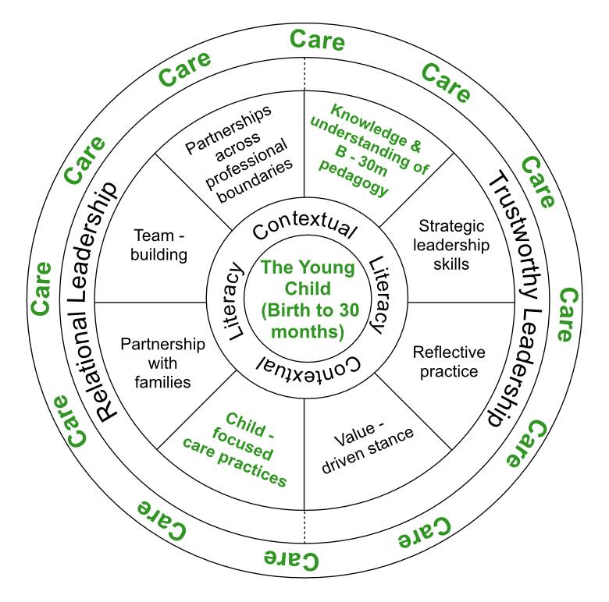
In defining mindfully caring leadership, I acknowledge the work of Rockel (2009, p.1) which urged a move ‘beyond the margins of minding babies…’ and the difference identified by Powell and Goouch (2012, p. 5) in their study with baby room practitioners between ‘minding babies and the mindful care of babies’.

Implications for practice
If the figure above addresses my first research question then what of the second question about what can be learned from the EYPs in this study? Again, acknowledging my own construction of the data, nonetheless I believe the following characteristics of graduate pedagogical leadership with children Bt30m (Figure 2) are drawn from the data and add further elucidation to the model in Figure 1. They are not presented in hierarchical order, rather they are randomly positioned and should not be viewed as unhelpfully limiting or overly-prescriptive. Instead, they are offered as a framework for praxis in pedagogical leadership with children Bt30m and might be used effectively in leadership formation and development, rather than as a specific model for training. Such praxis can enable the application of theory to lived practice as informed action (Freire, 1970). In identifying a framework for praxis, the present tense is used intentionally. This allows for personal interpretation and deep thinking about the characteristics of leadership and how these might be lived out within the leaders’ own context.

Figure 2: Characteristics of Mindfully Caring Pedagogical Leadership as praxis with children Birth to 30 months

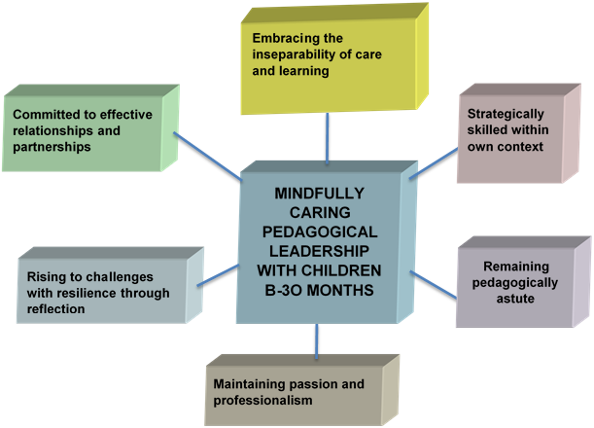

Furthermore, the research data suggests that there is further scope for the articulation of a pedagogy of care as a paradigm for work with children Bt30m, as this would herald a clear ‘shift to an educational framework’ (Rockel, 2009, p.1) for work with babies and toddlers. Given the unhelpful historic legacy which separates education’ for over-threes from ‘childcare’ for under-threes, the articulation of an appropriate pedagogical paradigm for work with children B-30m is to be welcomed. The very significant developmental trajectory from birth to thirty months suggests this might be considered discretely for babies and toddlers.

Only one of the six participants in the study believed she was part of an effective community of peer professionals. Others expressed frustration about not being part of such a community of practice (Wenger, 1988). This aspect of the data suggested that exploration of ways to establish – or more effective use of existing – networks to allow greater information exchange, agency, dialogue and critical engagement is crucial if a stronger collective voice of those graduates who lead pedagogical practice with children from Bt30m is to be heard by academics and policy makers. Indeed, this would include political awareness activity (Rodd, 2013).

In interrogating and unpicking the narratives of six EYPs, I contend that this study is contributing to increased understanding that caring for and leadership of practice with babies and toddlers is - or should be - positioned within a pedagogical framework. Using a model of mindfully caring leadership, graduate pedagogical leaders with children B-30m embrace strong relationships and trustworthiness. Many children Bt30m are now in out-of-home settings for at least part of the working week (Smith et al., 2010) and there is no indication this will wane in the future. These youngest children need and have a right to the most mindfully caring practitioners and leaders, who – in turn – have a right to be heard.
_________________________________________________________________________________
How to cite this study: Whalley, M.E. (2017) The role of the graduate pedagogical leader with children from birth to thirty months. Unpublished Ed.D. thesis. Leeds: Leeds Beckett University. KINDLY NOTE THAT THE FIGURES ON PAGES 7 AND 8 ARE COPYRIGHT AND NOT TO BE USED WITHOUT PERMISSION OF THE AUTHOR. whallmary@btinternet.com
__________________________________________________________________________________
References
British Educational Research Association (BERA) (2011) Ethical Guidelines for Educational Research. London: BERA.

Chalke, J. (2015) Negotiating and developing professionalism; early years practitioner’s stories of professionalism. Unpublished doctoral thesis, University of Sheffield.

Charmaz, K. (2008) ‘The legacy of Anselm Strauss for constructivist grounded theory’, in N. Denzin and Y. Lincoln (eds.) Studies in Symbolic Interaction Volume 32. Bingley, UK: Emerald Group.

Children’s Workforce Development Council (CWDC) (2006) Early Years Professional Standards. [Internet], CWDC. Available from: http://www.lancsngfl.ac.uk/curriculum/early_years/download/file/Draft_EYP_Standards_Aug_2006.pdf (Last accessed 25 October 2017).

CWDC (2008) Guidance to the Standards for the Award of Early Years Professional Status. Leeds: CWDC.

Cohen, L. and Manion, L. (2011) Research Methods in Education 7th edition. Abingdon: Routledge.

Creswell, J. W. (2013) Qualitative Inquiry and Research Design: Choosing Among Five Approaches 3rd edition. Thousand Oaks, CA: Sage.

Dahlberg, G., Moss, P. and Pence, A. (2013) Beyond Quality in Early Childhood Education and Care: Postmodern Perspectives. London: Falmer Press.

Degotardi, S. and Pearson, E. (2014) The Relationship Worlds of Infants and Toddlers. Maidenhead: Open University Press.

Department for Education (DfE) (2013) Consultation on Teachers’ Standards (Early Years). London: DfE/Teaching Agency. [Internet]. London, DfE. Available from: https://www.gov.uk/government/uploads/system/uploads/attachment_data/file/320247/Consultation_on_Teachers_Standards.pdf (Last accessed 25 October 2017).

Department for Education and Skills (2001) Early Years Sector Endorsed Foundation Degree: Statement of Requirement. London: HMSO.

Fernyhough, C. (2008) The Baby in the Mirror. London: Granta Publications.

Freire, P. (1996) Pedagogy of the Oppressed 2nd edition. London: Penguin.

Hadfield, M., Jopling, M., Royle, K. and Waller, T. (2011) First National Survey of Practitioners with Early Years Professional Status. [Internet], Centre for Developmental and Applied Research in Education (CeDARE), University of Wolverhampton/CWDC. [Internet], CeDARE/CWDC. Available from: <https://www.gov.uk/government/publications/first-national-survey-of-practitioners-with-early-years-professional-status> (Last accessed 25 October, 2017).

Hadfield, M. Jopling, M., Needham, M., Waller, T., Coleyshaw, L., Emira, M. and Royle, K. (2012) Longitudinal Study of Early Years Professional Status: an exploration of progress, leadership and impact. Final Report. RR DFE – RR239c. [Internet], CeDARE/DfE. Available from: <https://www.gov.uk/government/uploads/system/uploads/attachment_data/file/183418/DfE-RR239c_report.pdf> (Last accessed 25 October, 2017).

Law, S. and Glover, D. (2000) Educational Leadership and Learning: Practice, Policy and Research. Buckingham: Open University Press.

Mathers, S., Ranns, H., Karemaker, A., Moody, A., Sylva, K., Graham, J. and Siraj-Blatchford, I. (July 2011 – but commissioned before the Coalition Government was formed) National Evaluation of the Graduate Leader Fund – Final Chapter. Research DFE-RR 144. [Internet], London, DfE. Available from: <https://www.education.gov.uk/publications/standard/publicationDetail/Page1/DFE-RR144> (Last accessed 25 October 2017).

McDowall Clark, R. and Murray, J. (2012) Reconceptualising Leadership in the Early Years. Maidenhead: Open University Press.

Miles, M.B. and Huberman, A.M (1994) Qualitative data analysis: an expanded sourcebook. Thousand Oakes, CA: Sage.

Miller, L. (2008) ‘Developing professionalism with a regulatory framework in England: challenges and possibilities’, European Early Childhood Education Research Journal, Special Edition on Professionalism, 16(2): 255-269.

National College for Teaching and Leadership (NCTL) (2013a) Teachers’ Standards (Early Years) From September 2013. [Internet], London: Crown/NCTC. Available from: https://www.gov.uk/government/uploads/system/uploads/attachment_data/file/211646/Early_Years_Teachers__Standards.pdf (Last accessed 25 October 2017).

National Foundation for Educational Research (NFER) with CWDC (2009) Evaluation of the career development of Early Years Professionals (EYPs) Key Findings. [Internet], NFER. Available from: http://www.nfer.ac.uk/publications/REYZ01/REYZ01_home.cfm (Last accessed 25 October 2017).

Oberhuemer, P. (2008) ‘Who is an early years professional? Reflections on policy diversity in Europe’ in Miller, L. and Cable, C. (eds.) Professionalism in the Early Years. London: Hodder and Stoughton.

Otkay, J.S. (2012) Grounded Theory. New York, NY: Oxford University Press.

Powell, S. and Goouch, K. (2012) ‘What in the world is happening to babies? A critical perspective of research and support for baby room practitioners in England.’ Keynote address at the 2013 Annual Conference of TACTYC, Birmingham, November. [Internet], TACTYC. Available from: <http://www.tactyc.org.uk/pdfs/Reflections-Powell-Goouch.pdf> (Last accessed 25 October, 2017).

Remus, U. and Wiener, M. (2010) ‘A Multi-Method, Holistic Strategy for Researching Critical Success Factors in IT Projects’, Information Systems Journal, 20(1): 25-52.

Riessman, C. (1995) Narrative Analysis. Qualitative Research Methods Series 30. London: Sage.

Rockel, J. (2009) ‘A pedagogy of care: moving beyond the margins of managing work and minding babies’, in Australian Journal of Early Childhood, 34(2): 1-8.

Rodd, J. (2013) Leadership in Early Childhood: the pathway to professionalism. 4th edition. Maidenhead: Open University Press.

Siraj-Blatchford, I. and Manni, L. (2007) Effective Leadership in the Early Years Sector: The ELEYS study. London: Institute of Education, University of London.

Smith, R., Poole, E., Perry, J., Wollny, I., Reeves, J., with Coshall, C. and d’Souza, J. (2010) Childcare and Early Years Survey of Parents 2009. Nottingham: DCSF Publications.

Sylva, K. Melhuish, E.C., Sammons, P., Siraj-Blatchford, I. and Taggart, B. (2004) The Effective Provision of Pre-School Education (EPPE) Project. The Final Report. [Internet], London: DfES. Available from: http://eprints.ioe.ac.uk/5309/1/sylva2004EPPEfinal.pdf (Last accessed 25 October 2017).
Wenger, E. (1998) Communities of Practice: Learning, Meaning and identity. Cambridge: Cambridge University Press.

