Pedagogical Documentation: a Hungarian perspective
Bernadett Nagy

Ethically, all children should be considered as individuals who “… develop at their own rates, and in their own way”(DfE, 2012). Each professional within the Early Years Education system is also an individual with different experiences, beliefs and mental constructions. Thus, it is good practice to expect from ourselves as educators and pedagogues what we expect from children; lifelong learning and the desire to improve our minds.
Although some people might believe predictability is safer in terms of outcomes, having a fixed mindset does not lead to stability. Looking for opportunities to take on a challenge and learn from mistakes is a way to move forwards, as is accepting that creativity is based on transformation and the ability to adjust.

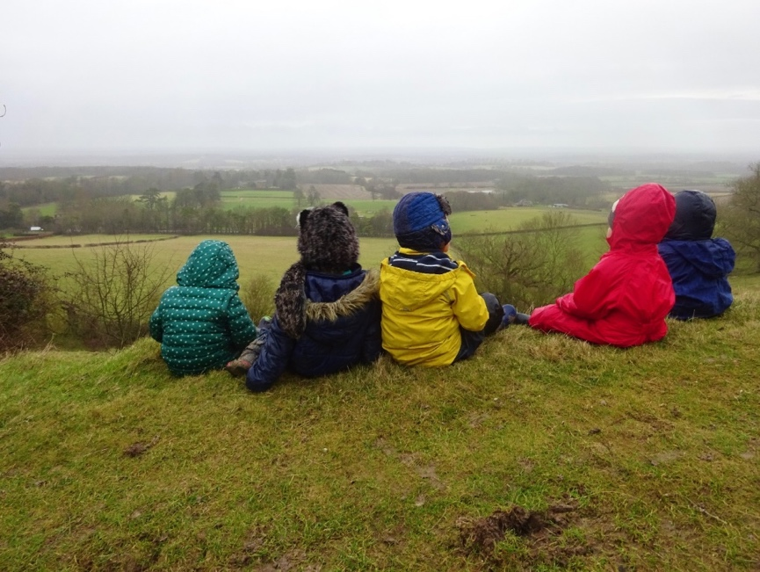

Values and political priorities are highly dependent on cultural understanding and reflect one’s knowledge on the nature of child-development (Rosenthal, 2003). In my role of helping young children to realise their potential, I use a pedagogical concept that is very significant in Hungarian early childhood education: nevelés.
…the closest translation being “upbringing”. It is a holistic concept, including not just care and education …, but also health, behaviour, and social skills – everything needed in life. It has, therefore, much in common with the concept of ‘social pedagogy’ … “Nevelés” expresses that care and education are inseparable concepts. When you provide care, you also teach children directly or indirectly and vice versa. In other words, it relates to “pedagogy”.
(Korintus, 2012. P.4 in OFI, 2012)

My pedagogy has been shaped by people I have come across in my life, including each child, parent and colleague. My professional pedagogical identity, primarily influenced by the values of Hungarian society have also changed in the past few years within the English context. This document was developed through several months to chronicle a period of countless modifications and transformations, not only within nature, but also in children and my personal professional practice. Capturing moments through photography and reflective notes encouraged greater awareness of pedagogical approaches, grounded in the holistic concept of nevelés and based on accepting change.

I became aware through first-hand experience that making statements about my personal values in relation to working within early childhood education and care is neither simple nor static.
“Rating scales, check lists, standardised protocols and procedures, detailed systems of inspection - these are the methods and tools of quality. Meaning making takes a quite different approach: it works with pedagogical documentation and reflection, and through listening.” (Dahlberg, Moss and Pence, 2013)

Understanding Nature = Understanding child development
Nature is more than a set of phenomena with the focus on plants and creatures: nature is the whole world we live in. So, when I talk about Nature, it is the ‘interconnectedness’ and ‘unity’ emphasised by Friedrich Froebel. Nature is everywhere so I welcome opportunities to spend a day in an open space with the children. These spaces allow us to play with the resources they offer, to explore their features, talk about them, stay silent, challenge ourselves both mentally and physically within these boundaries, either independently or with support from others.

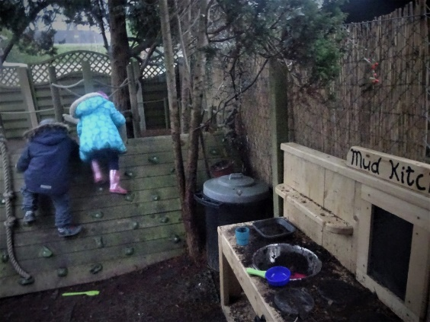

Children feel the urge from an early age to interact with their environment, actively explore and make sense out of it. During the first year, children display subjective motives by exploring objects and intersubjective motives through engaging in playful activities with others (Trevarthen and Aitken, 2001). At a later stage more complex awareness is evident in secondary intersubjectivity, exploring an object with another person. This is recognised in the New Zealand curriculum, Te Whariki, which acknowledges that children's working theories develop when opportunities are provided to engage, interact, participate and discuss a variety of topics through activity (Ministry of Education, 1996).

Froebelian pedagogy promotes shared experiences, where children work alongside others to solve problems with support or guidance. At the same time trustful relationships develop through active play, helping children to recognise their own place in society (Liebschner, 2001) and see themselves as autonomous beings.

I observed children’s play in two types of outdoor environment. One is a closed garden attached to the nursery school and the other a forest school with open outdoor space and opportunities explore tracks and go for walks.

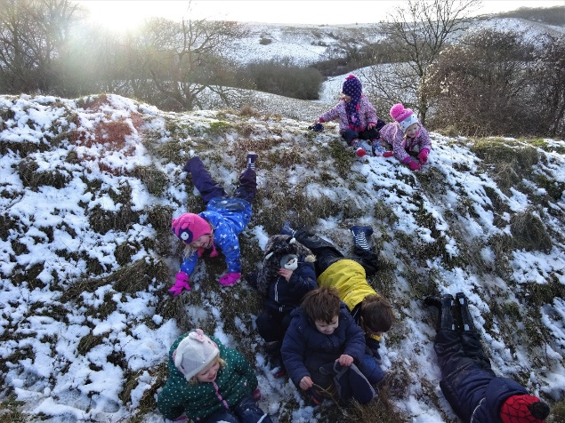

Forest schools, woodland and green spaces have many benefits for children's development. Access to nature not only improves confidence, concentration and communication skills, but also helps children develop into physically able and emotionally stable individuals (O’Brien, 2009). It also counteracts something defined by a relatively new term, Nature Deficit Disorder (Moss, 2012).
Pedagogues can promote active learning, creative and critical thinking by providing a variety of interesting, engaging, play-based opportunities that are motivational and encourage curiosity. This pedagogical approach requires the ability to think in a variety of ways (Cremin, Burnard and Craft, 2006). The concept of ’possibility thinking’, just like the ’working theory’ may apply to both adults and children, and using it as a reflective tool can improve professional practice.

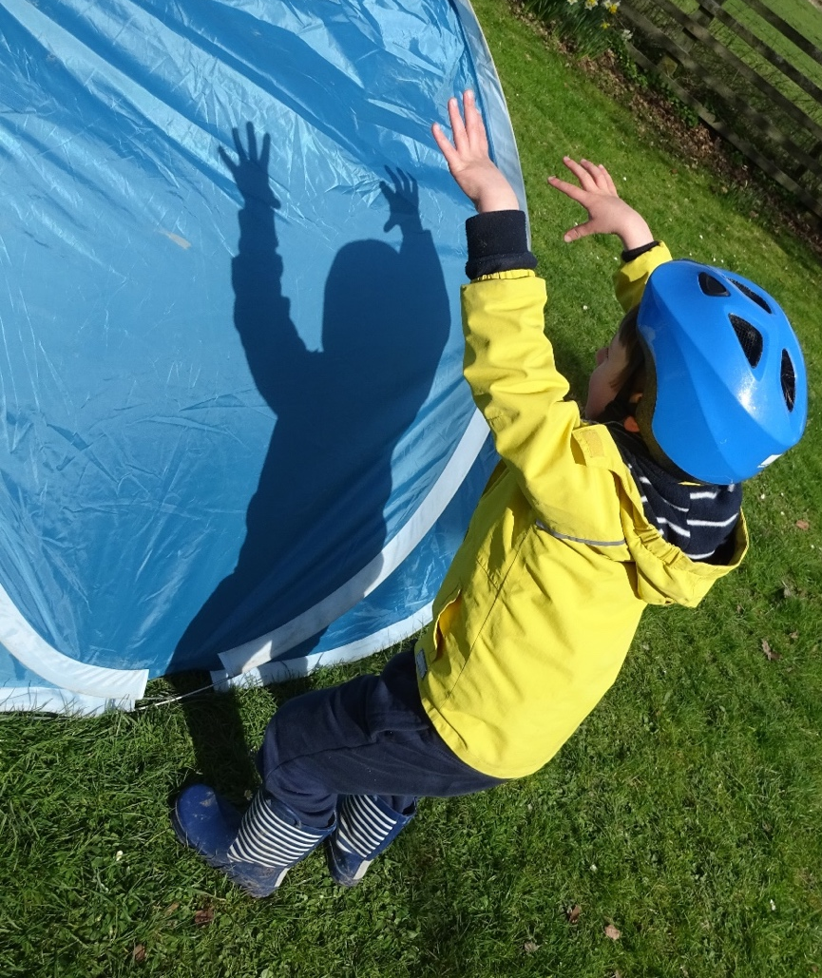

The picture above captures a child playing shadow theatre completely free of adult support and guidance. Two children became aware whilst hiding in the tent from the wind, that every time someone moved past, shadows appeared in different shapes. They started to take different roles, acting as monsters, dinosaurs and other scary creatures and inviting others to join in. Children independently named the game the shadow theatre and took turns to watch from the inside or playshadows together from the outside. Clearly nature played a big part in developing this idea, as the sun shining behind the children made the game possible.
Opportunities are not just dependent on professionals' pedagogical attitude but their possibility thinking also enables children to use resources in a variety of ways and learn from them. Seeing the possibility in natural features, identifying opportunities and recognising how children can creatively use combinations of resources helps to grow potential. Looking at the open space in the morning I had to assess resource options in relation to the weather. The tent provided a place to hide from the wind, however children began to develop the available resources by exploring, watching and thinking, and by means of communication in a social context.

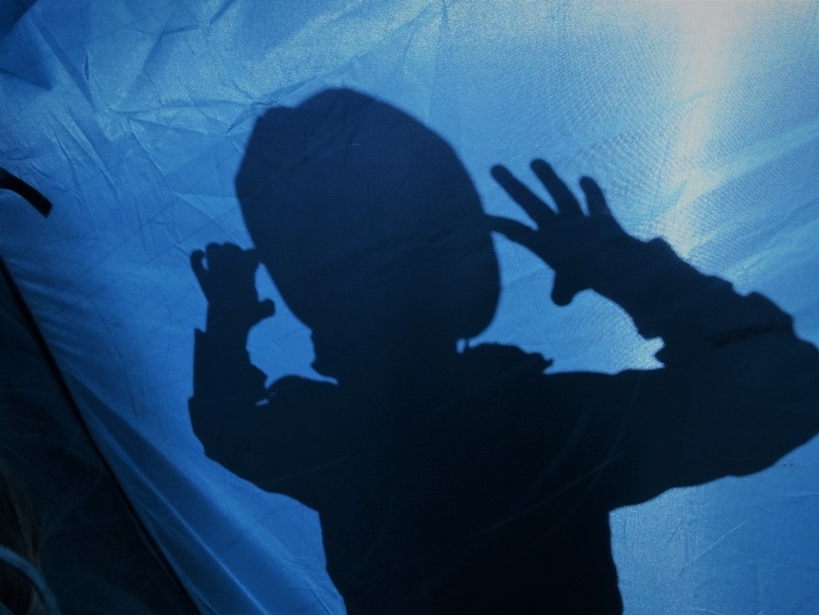

The Role of the Pedagogue: Preparing or Allowing Children?
Space must be provided beyond the classroom for development. English early childhood education policy emphasises 'school readiness' and can be misleading, not only to anxious parents, but practitioners can be pressurised by strict guidelines and narrow focuspoints (McDowall Clark, 2017; Neaum, 2016). Instead of making transition an enjoyable and exciting process, it becomes stressful for all participants.
As a pedagogue my aim is to support childen and parents in making sense of the developmental process and to promote valuable learning experiences, taking time and space into account throughout the journey (Cremin, Burnard, Craft, 2006). When time and space is given to children it empowers them and enhances intrinstic motivation. My experience in connection with children’s learning within open and closed outdoor spaces, enhanced my own pedagogical learning as well through considering how children behave in limited space with finite opportunities compared with how they act and learn within open spaces. Documenting my personal pedagogy forced me to reflect in more holistic ways, looking at the place and space as an opportunity for children’s vertical and horizontal transition; learning through play; and growth, both physically and mentally within a natural environment.
Whether open or closed by gates, both spaces are enabling in their own way, however many children who started to attend both settings on a weekly basis showed skills and abilities that were difficult to identify if they were only engaged in one type of setting. By using pedagogical documentation, it becomes possible to capture a moment to highlight how one has been challenged by a new opportunity. This reflects Craft’s (2002) work, extending the dimensions of learning from lifelong to ‘lifewide’; she criticised the idea of ‘creative development’ (introduced in an earlier version of the EYFS) for its suggestion that creativity can be developed, as that suggests an end state or closure.

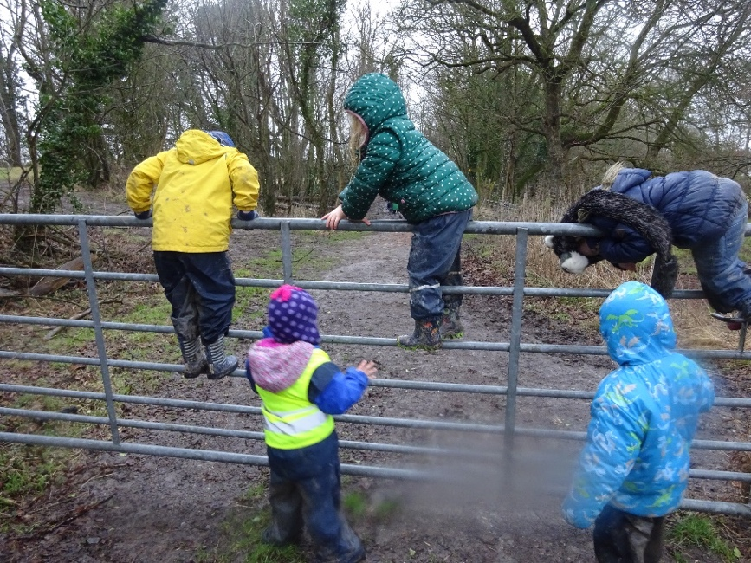
“When we want to examine the adult role we have to start from the child. What children are like – or what we think they should be like – influences our constructions of the ideal adult role.” (Kalliala, 2011: 238)

The picture above shows how children took risks climbing through an iron gate that was slippery and cold from rain earlier that day. Next to this gate was an open door, but the children showed no interest in walking through it. Responsible for children’s well-being and the health and safety of activities, alongside the forest school teacher, at this particular moment I was challenged by various possibilities of the environment; I needed to listen, take advice from my experienced colleague and look at the situation from a distance.
Risk anxiety and fear that children might physically injure themselves often affect professionals' decision making (Bundy et.al., 2009). Although I highly value children’s independent decision making, I had to put my value based theory into practice. The consequence of narrowing down the focus to potential for physical injuries creates dilemmas regarding responsibilities.
Restricting children’s independence in their exploration of danger within the environment carries other types of risks. Too great a focus on physical injury may reduce opportunities for active play. As physical activities provide health benefits and a chance to teach children to use their bodies actively this risk is greater than we might expect at first. It goes beyond restraining children from active physical play; it holds them back from achieving goals. Moreover, it is about exteriorizing our own fear. My first instinct was to stop children climbing through the gate, but the reaction of my colleague helped me think it through and allow them space. In this situation we should think of ‘playable spaces’ that connect children’s primary action with the context within which action happens (Children’s Play Council, 2002).
Some children needed verbal encouragement and others asked for physical support, but they were proud of their achievements. It was a moment of developing my working theory that should help my pedagogy in the future when similar situations arise. Letting children actively explore and take risks is easier when pedagogues realise the variety of possibilities that can lead to positive outcomes. Besides, children also learn from each other and through each other whilst engaging in play-activities, which emphasizes how children can use someone as a reference point in order to create their own ideas (Liebschner, 1985).

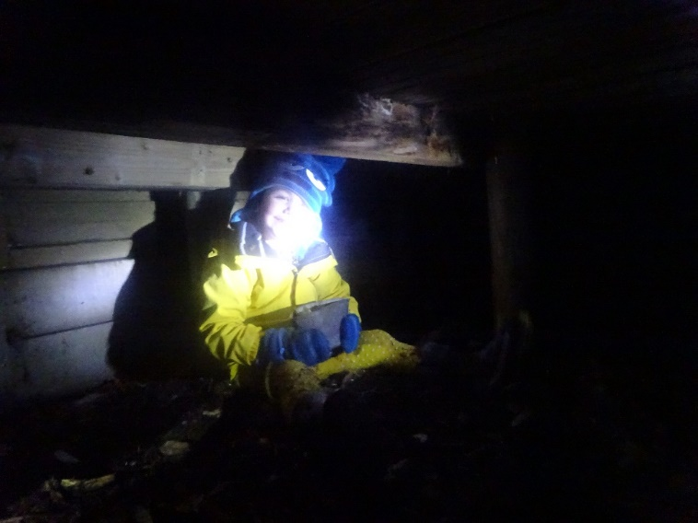
“The dark peeks around the corner and waits behind the door, and you can see the dark up in the sky almost every night, gazing down at you as you gaze up at the stars.” (Lemony Snicket, The Dark, 2013)

Nature offers endless opportunities and with creativity it is possible to turn negative attitudes into positive, playful learning experiences. The last thing that I attach to long English winter nights are positive and cheerful thoughts but as a role model within early childhood education I need to consciously work on my attitudes in relation to what nature offers. Teaching children to accept a situation and bring the most out of it is a constant working theory for both me and them. We teach each other new ways of perceiving the world and adapting to new situations. Whether it is too cold, too hot or too dark outside it doesn’t change children’s natural desire for play and their urge to discover.

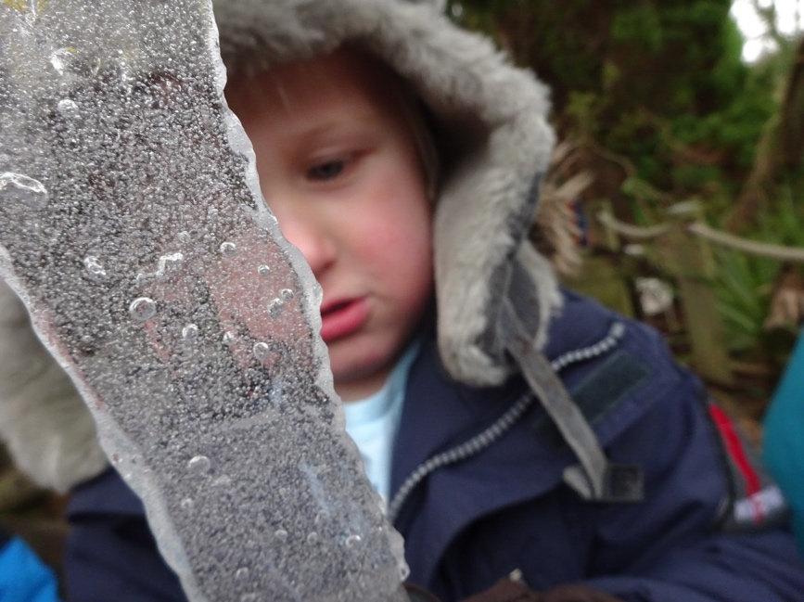

Just like in Lemony Snicket’s children’s story about the dark that is physically omnipresent around us at night, the Froebelian ‘Unity’ and ‘Connectedness’ surround us within our physical space. When the valuable opportunities provided by nature are recognised, it enables us to work on some of our false beliefs and misconceptions, make new links and grow better understanding.

References:
Bundy, A.C., Luckett, T., Tranter, P.J., Naughton, G.A., Wyver, S.R., Ragen, J. and Spies, G. (2009) The risk is that there is ‘no risk’: a simple, innovative intervention to increase children’s activity levels. International Journal of Early Years Education, Vol 17(1): 33-45.
Children’s Play Council. (2002) Managing risk in play provision Available at: http://www.playengland.org.uk/media/172644/managing-risk-in-play-provision.pdf
Craft, A. (2002) Creativity and Early Years Education: A lifewide foundation. Bloomsbury Publishing.

Cremin, T., Burnard, P. and Craft, A. (2006) Pedagogy and possibility thinking in the early years. Thinking skills and creativity, Vol 1(2):108-119.
Dahlberg, G., Moss, P., and Pence, A. (2013) Beyond Quality in Early Childhood Education and Care: Languages of Evaluation. London: Routledge
Kalliala, M. (2011) Look at me! Does the adult truly see and respond to the child in Finnish day-care centres? European Early Childhood Education Research Journal, Vol 19 (2):237-253.
Liebschner J. (2001) A child's work: freedom and guidance in Froebel's educational theory and practice, Cambridge: Lutterworth.
Liebschner, J. (1985) Children learning through each other, Early Child Development and Care, Vol 21 (1-3):121-134.

Ministry of Education (1996) Te Whāriki. He whāriki matauranga mo nga mokopuna o Aotearoa: Early childhood curriculum. Wellington: Learning Media.

Moss, P. and A. Pence, eds. (1994) Valuing quality in early childhood services: New approaches to defining quality. London: Paul Chapman.
Moss, S. (2012) Natural childhood. National Trust Publication. Available at: file:///C:/Users/hunting4/Desktop/Lindafield/ped.doc/olvas/natural_childhood%20REPORT.pdf (Last accessed: 08. 05. 2017)
McDowall Clark, R. (2017) Exploring the contexts for early Learning: challenging the school readiness agenda Abingdon: Routledge.
Neaum, S. (2016) School readiness and pedagogies of Competence and Performance: theorising the troubled relationship between early years and early years policy. International Journal of Early Years Education, Vol 24(3): 239-253.
O’Brien, L. (2008) Learning outdoors: the Forest School approach, Education 3–13 Vol 37 (1): 45–60.
OFI, (2012) Early Childhood education and Care: Specificities of the Hungarian System Available at: http://ec.europa.eu/dgs/education_culture/repository/education/policy/strategic-framework/doc/hungarian-ecec-specificities_en.pdf (Last accessed: 08. 05. 2017)
Rosenthal, M.K. (2003) Quality in early childhood education and care: A cultural context. European Early Childhood Education Research Journal, Vol 11(2):101-116.
Snicket, L. (2013) The Dark, UK: Orchard Books
Trevarthen, C. and Aitken, K.J. (2001) Infant intersubjectivity: Research, theory, and clinical applications. Journal of child psychology and psychiatry, Vol 42(1):3-48.

