The Red Blanket: sensing difference in body play
This briefing reports on findings discussed in a recently published paper:
MacRae, C. (2019). The Red Blanket: A dance of animacy. Global Studies of Childhood. https://doi.org/10.1177/2043610619832899

Aims and Context
This TACTYC briefing reports on data that has been analysed to explore the value of the sensorimotor play of 2-year olds. Pushing back against a narrative of developmental progression, the discussion will be focused on the improvisational performance of small physical acts that take place in the body play of very young children. The research offers a strong argument for ‘attuning’ practitioners to the pedagogical significance of moving bodies in the context of early childhood education. By foregrounding bodily experience, the discussion expands and builds on understandings of the popular idea of sustained-shared thinking. If thinking was not contained within each body, but was more distributed and sensed through these minor moments, then shared thinking is also about the shared experience of physical movement. The data presented also has a particular relevance in reframing rough-and-tumble play as a kind of thinking in action, where entangled bodies sense their own and each other’s changing capacities.
The context behind the research is anxieties about the education gap between richest and poorest, where 2-year olds have become central to concerns about ensuring normative development for all children. It is these policy concerns that have led to funded nursery places for disadvantaged 2-year olds. Increasingly I have found myself interested in the pressures that the discourses of early identification and the ‘word gap’ place upon practitioners in terms of trying to maintain an intuitive ethics of care whilst also being enmeshed in a discourse of developmentalism and identification of delay.

Methodology and methods

In this research project, I adopted a methodology of “Slow Research” (Horton and Kraftl, 2006; Millei and Rautio, 2017). While the project was located within the tradition of ethnography, as the research unfolded the concept of researcher-in residence emerged as a unique aspect of the relationship that evolved over the longer time frame of two years. During this time, I spent one day a week in the 2-year old funded Nursery Class at Martenscroft Nursery School and Children’s Centre in Manchester. My position in the classroom was as a participant and a documenter. Initially I tried to take fieldnotes, but increasingly I found that written on-the-spot, or after-the-event observations were insufficient to capture the complexity of play events as they unfolded. My attempts to document decreased as my immersion in the flow of classroom life increased. While I did not consciously adopt a least-adult role (Mandell, 1988), my role was certainly different to other adults as I did not have the keyworker or daily routine responsibilities; it was a position that offered me more space within which to take a ‘play-mate role’ (O’Connor and Daley, 2016:32). I found that the best form of documenting classroom life was using video, however, I tried to keep this minimal so that I did not end up with too much film data. By the end of the first year, the use of slow-motion video became a key source of data because it made perceptible micro-gestures that are often below the threshold of adult perception.

Using posthuman theory

I have used post-human theory (Murris, 2016) as the lens through which I view my data. This is in order to draw attention to ways that children respond through their senses to the material qualities of the environment. In particular I have used Erin Manning’s (2016) idea of the minor gesture, as a way to re-activate what Piaget describes as the sensory-motor stage – and to consider the possibility of re-conceptualising the sensory-motor more as an ongoing minor key that has the potential to pulse through life beyond infancy. To talk about a post-human child can seem like a bizarre direction to take given that early years practitioners and researchers have, for good reasons, in the past (as well as in the present) fought to put the child at the centre of their practice. However, as Goodley and Runswick Cole observe, the figure of the human child at the centre of our practice is also bound up with how we conceptualise the human: it’s a conceptualisation of “a bounded, rational, independent, individual self” (2016:8). This can lead us to value particular ways of acting over others. Play can become a narrative of cognitive mastery and ability – mastery of self and of the world. This humanist figure of the child is extracted from its environment, and is recognised as the sole locus of agency. Play runs the risk of becoming what Olsson’s calls a “pre-determined map” (2009:3) through which a child performs the ‘normal’ stages of development as shaped by the Early Years Foundation Stage curriculum (which is still closely aligned with Piaget’s stages of development), with the final destination being reason and language.

Although Piaget’s cognitive approach has been very much modified by socio-cultural theory which re-situates the child into a web of social relations, the idea of the human as a bounded knowing subject underlies both the cognitive as well as social constructions of the child. Murris also points out other continuities between these two dominant constructions of the child; she observes that while Piaget’s cognitive mapping of childhood leaves out the social, and the socio-cultural mapping leaves out the physical, biological and material, this ensures that there is a continuing “indivi-dualism” which she calls the “story written in our bones” (2016:46). Expanding on some aspects of the cognitive and social constructions of the child, but at the same time, dis-lodging the human at the centre of all agency, posthuman theory refigures agency as more distributed across human and non-human bodies. In this reconceptualization, it is not only the child who acts on the world, but materials also act on the child; intra-action rather than inter-action (Barad 2007). The posthuman child is constructed “as entanglement; constituted by concepts and material forces, where the social, the political, the biological … are interwoven and entwined– all elements intra-act and in the process ‘lose’ their boundaries” (original emphasis Murris 2016, 91).

Barad’s term “intra-action” de-centres humans, giving the more-than-human agency. She draws our attention to the way that we are always in relation with other bodies, both human as well as non-human. Building on Änggård’s research in an early years classroom, my initial research questions were interested in developing a re-conceptualist reading of Piaget’s sensory-motor stage, by exploring how ‘matter seems to talk more directly to children’s hands and bodies’ (2016:7). Rather than a focus on mind over matter, this brings to the surface the ways that children play with matter, as well as the way that matter plays with children. Approaching my data through the more-than-human has allowed me to try to open play as radically as possible in order to include play events that seem to resist or sit uneasily as ‘proper play’. Instead, I have focussed on movement as a relationship of encounter between human and non/human, and a more dynamic and materialist account has emerged. This focus on a moving and sensing body also responds to Peter Moss’ invitation to envisage early childhood institutions as sites for democratic ‘minor’ politics by paying attention to the “ethics of the encounter” (2006:129).
The data
The use of slow-motion film has offered me a method that attends more fully to the in-the-moment unfolding of play events. In contrast to writing observations, film keeps the action of bodies in motion, and because I can slow it down and re(view) clips again and again, I am able to notice the dynamic intra-actions that unfold in the moment. The piece of data I will refer to here is a very short clip from a much longer play event. In order to give a flavour of event I have translated the film data back into words and also traced images. I include a drawn image, as well as the transcribed vignette. The section of the film that I am choosing to focus on in this briefing is only a few minutes of a much longer play event. The whole filmed play event was 12 minutes long. It started when one child picked up a red blanket lying on the ground and started to run with it. In response to this another child, started to move towards the running boy/blanket and then became part of this moving bundle himself. Later another child joins in and the blanket is abandoned at various points as the boys encounter both a garage wall and some tree-stumps. Here I will just focus on the first few minutes of the event when two boys start to move around with the blanket.

Hand-traced image from film clip (MacRae, 2019)

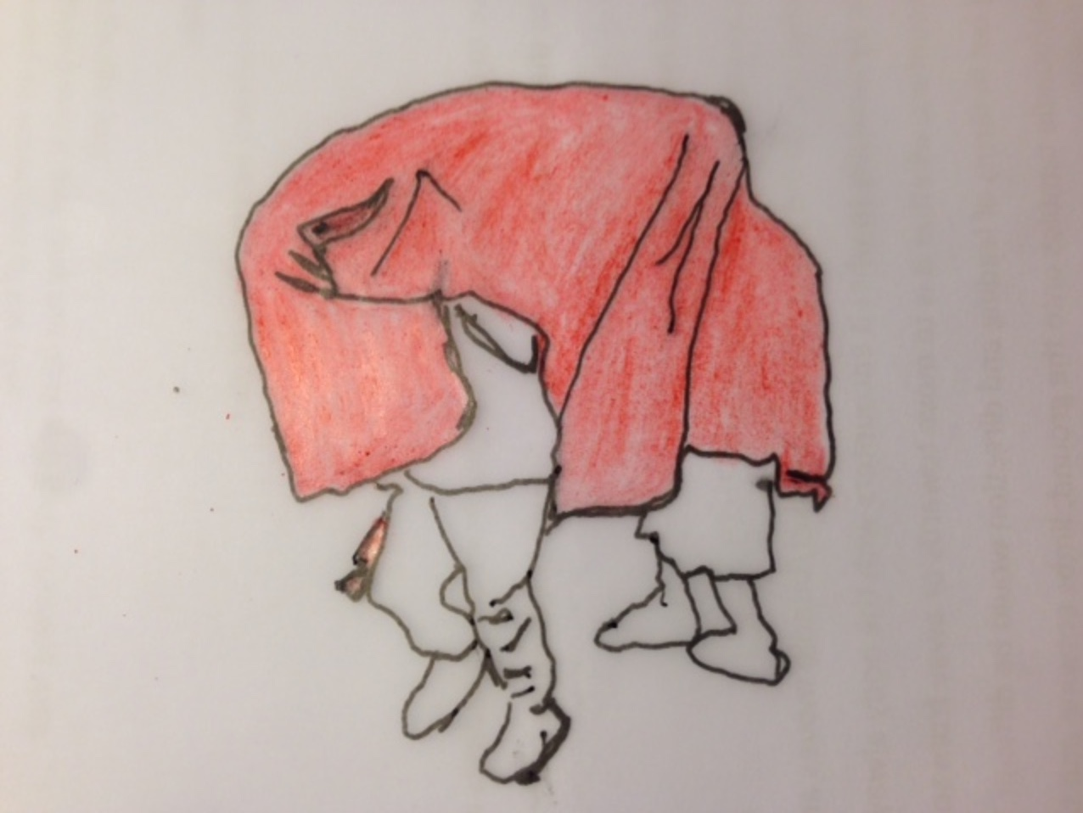

Data vignette, written as response to slow-motion film clip (MacRae, 2019)

‘I stand in the outdoor area and it is two children (S and K) playing with the Red Blanket that have caught my attention. The soft slightly furry blanket and the two children move around the space: sometimes they are blanketed, sometimes when it slips off they remain connected to each other as they hold onto the blanket. The blanket is also in motion; it sometimes slips away from them, working free as it responds variously to gravity, to the forward force produced by running limbs, and to the jerks and pulls of the boy bodies. When the bodies move in counter directions, the held blanket keeps the bundle together. I start to film this moving blanket-and-body bundle as it moves around the outdoor area. And just as my attention has been caught by the moving bundle, A’s attention has also shifted in its direction, and his body moves with this attention, towards the body/blanket bundle. A manages to keep hold of the basket-ball he is holding in one hand, while with the other he wrestles with the edge of the blanket using tugs and pulls. This repeated tugging results in the blanket slipping off K’s head accompanied by giggling shrieks from both K and S.’

Discussion and wider implications

In the slow-motion filmed rendering of the Red Blanket play event, what stands out, is the way that the boy/blanket/bundle moves around the space. The bundle seems to be dynamically and responding moment-by-moment to what it encounters. But at that same time the bundle is also always moving in anticipation of these encounters. So, it seems that the bundle starts moving towards the bark chipping area as if in anticipation of a softer surface onto which bodies call fall without injury, but at the same time, when bodies do fall onto the bark chippings, limbs are responding to gravity and the shifting weight of the entangled bodies as they meet the surface of the ground. To try and separate agency out in terms of a body that leads or directs would be difficult. When the boy/blanket/bundle tumbles onto the ground, limbs entwine and bodies roll over each other. The phrase ‘rough and tumble’ might come to mind. But slow-viewing shows a dance between the boy-bodies and blanket that is full of care. At times during the choreography of this dance intentional action can be glimpsed, for example when S’s arm pushes K’s chest down as they meet the ground. However, any intentionality is always shifting as one body encounters another, and as the bodies respond to the blanket, to the ground and to gravity: things always have the potential to re-align the body in a new direction as part of the improvisational impulse when a sensing body responds dynamically to the encounter as it moves. When slowed-down this improvisational element has a dance-like quality. Both Trevarthen (2002) and Raikes and Edwards (2009) note the way that caregivers of very young children often engage in dance-like exchanges of reciprocal responsivity. The slowed film of the boy/blanket/bundle reminds us that this tangle of agency extends beyond dyadic relationships between adults and children, to include more-than-human matter.

The part played by the blanket, the tarmac, the wood chippings, gravity (and more), are all animating part of what Ingold calls this ‘dance of animacy’ (2013:100). The Red Blanket sets the boys bodies in motion and the dance that emerges is less a conscious knowing mediated by a brain that has mapped where it is going, and more a creatively sensed way of being in the world. It is noteworthy that during the 12 minutes of the much longer event from which this vignette was taken, hardly any words are spoken, but what is striking is the depth of bodily communication and alignment between boys and blanket in relation to matter, as well as to each other. Manning’s idea that we should give value to the minor gesture can help us think more deeply about these kinds of play events and how we experience ourselves in motion. Her concept recognises the minor gesture as being characterised by emergent and improvisational; qualities that are alive with creative possibility. The minor contrasts with majoritarian developmental approaches to the production of knowledge that value an intentional mind over an attentional body. However, this overlooks a different kind of sensed intelligence that takes place in-the-moment as we dynamically interact with the world. In Manning’s words, “how we act is based on a continuous interplay of conscious and nonconscious movement with nonconscious movement playing a vital part, especially as regards movement’s creative potential” (2016:19). She asks us to linger in the unfolding of experience, to care for the event, by giving it more fully our attention. This allows us to hold its indeterminate character open, and see the creative dance of relation that unfolds. The minor is often expressed in micro-moments that we miss: hovering on the cusp between the unconscious and conscious, it reminds us that bodies can think through movement as they feel their way in response to the world.
In their research into practice and provision for 2-year olds, Powell and Goouch suggest that “intuitive scripts”, that are nurtured through “dialogic research and sensitive and informed development opportunities” (2014:33), might offer a space where practitioners can mediate their intuitive responses that sometimes sit in tension alongside the systemic scripts borne out of local and national policies. I would argue that viewing film in slow-motion, and using Manning’s concept of giving value to ‘minor gestures’ could be used as a technique that tunes adults into the everyday sensory worlds of children. An appreciation of the ways that children’s attune themselves to the more-than-human, as well as with the human, has the potential to expand on the popular idea of sustained-shared thinking (Ephgrave, 2017) that has gained currency early years pedagogy. Degotardi (2017) has pointed out that much research work on joint shared attention has taken place in experimental settings, and also that the concept has tended to be weighted towards verbal dialogue. It might be that the focus on speech can blind us to other important ways of knowing the world. The early findings from my research residency push this concept beyond the cognitive and the social, challenging the notion that attention is contained within individual bodies. Instead, I propose that attention is more distributed and sensed through minor moments of encounter: joint attention then becomes more a question of a shared “emergent mattering” (MacRae, 2019:9).
References:
Änggård E (2016) How matter comes to matter in children’s nature play: Posthumanist approaches and children’s geographies. Children’s Geographies, 14(1): 77–90.
Barad KM (2007.) Meeting the Universe Halfway: Quantum Physics and the Entanglement of Matter and Meaning. Durham, NC: Duke University Press
Degotardi, S. (2017). Joint attention in infant-toddler early childhood programs: Its dynamics and potential for collaborative learning. Contemporary Issues in Early Childhood, 18(4), 409–421

Ephgrave A (2017) Planning in the Moment with Young Children: A Practical Guide for Early Years Practitioners and Parents, Oxon: Routledge
Goodley D and Runswick-Cole K (2016) Becoming dishuman: Thinking about the human through dis/ability, Discourse: Studies in the Cultural Politics of Education, 37(1): 1–15.
Horton J and Kraftl P (2006) What else? Some more ways of thinking and doing ‘children’s geographies’. Children’s Geographies, 4(1): 69–95
Ingold T (2013) Making. Anthropology, Archaeology, Art, and Architecture. London: Routledge
MacRae, C. (2019) The Red Blanket: A dance of animacy. Global Studies of Childhood, https://doi.org/10.1177/2043610619832899

Mandell, N. (1988) The Least-Adult Role in Studying Children. Journal of Contemporary Ethnography, 16(4), 433–467
Manning E (2016) The Minor Gesture. London: Duke University Press
Millei Z and Rautio P (2017) ‘Overspills’ of research with children: An argument for slow research. Children’s Geographies 15(4): 466–477
Moss, P. (2006) Early Childhood Institutions as Loci of Ethical and Political Practice
International Journal of Educational Policy, Research, & Practice: Reconceptualizing Childhood Studies (7)
Murris K (2016) The Post-Human Child: Educational Transformation through Philosophy with Picturebooks. London: Routledge

O’Connor, A. and Daley, A. (2016) Understanding Physical Development in the Early Years, Oxon: Routledge

Olsson, L (2009) Movement and Experimentation in Young Children’s Learning: Deleuze and Guattari in Early Childhood Education. London: Routledge
Powell, S. and Goouch, K (2014) Two-Year-Old Children in Three Counties: Improving provision through research-led development, Canterbury: Canterbury Christ Church University
Raikes H. and Edwards C. (2009) Extending the Dance in Infant and Toddler Caregiving, Enhancing Attachment and Relationships, Baltimore: Brookes Publishing
Trevarthen C, and Malloch S, (2002) Musicality and music before three: Human vitality and invention shared with pride, Zero to three 23(1): 10-18.

