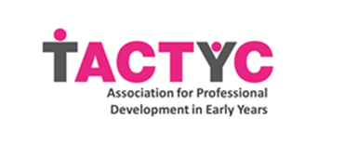
Membership Report June 2021

Last year a temporary membership of £5 was introduced to support the sector during the pandemic. Unfortunately, the pandemic is still very much with us and the early years sector continues to feel the effects of chronic under funding. As an organisation, the decision was made to extend the temporary membership in recognition of this.

Our current membership stands at 192 (one less than this time last year).

Our current membership includes:

As a membership organisation, TACTYC’s strength lies in the expertise, varied perspectives, and commitment of its members. We seek to represent your views and interests and to meet your needs within all of our activities. To this end, we asked you for you to tell us which of our activities you find most valuable. While the response rate was low, the top three were the website, journal and occasional papers.

We also asked what you would like to see more of from us. Suggestions included more frequent communication, extending the webinar series (which we hope to make available through youtube by the end of the month), providing more opportunities for early career researchers to share their work, and the production of briefing papers on government policy. We will be developing these aspects of our work and exploring ways to expand our membership over the next year.

Viki Veale
Membership Director
June 2021

