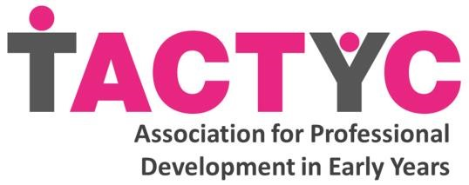

TACTYC AGM Minutes

Virtual
19.06.21

Present: Angela Scollan, Karen Boardman, Wendy Scott,
Rod Parker-Rees, Viki Veale, Sherron Curtis, Penny
Borkett, Natalie Canning, Elizabeth Carruthers, Rory McDowall-Clark
Plus 31 TACTYC Members (tbc)

Apologies: None.

- Minutes of the last AGM:

Agreed.

- Matters arising from the Minutes:

No matters arising.

- Chair’s report:
Karen Boardman discussed the report and key headlines – successful year for TACTYC. New strapline, new communications, EDI training for the Board as part of the Strategic Plan. She gave an update of the work the charity has been doing in the last year and thanked Trustees, members and past members for their part in the TACTYC journey. Karen highlighted the congratulatory OBE accolade for Janet Moyles. Karen also thanked Rory for all her dedication, passion and hard work, as she is stepping down as a Trustee.

4. The Treasurer’s report

Natalie presented the budget report. The budget has been audited and approved. There is currently £55,605.42 in the bank. Predictions discussed.

The Board would like to extend an enormous thank you to Natalie for all the work she has done on the budget Treasurer.

5. Membership secretary’s report
Viki Veale explained that the charity’s strength lies in its membership. There is a wealth of experience and diversity in terms of where people work. The temporary and reduced membership meant a number of people have joined the charity and visited the website. Viki highlighted that at the conference there was an increased interest in membership.

6. Journal Editors report
Rod Parker-Rees explained the key headlines. The journal continues to grow and there are now five issues per year with four publication dates. Downloads are up and the publishers are happy. Social Science citations are up and this is a important metric for the status of the journal, which is growing. New editors are being recruited and the journals are now ‘plastic free’.

7. Website report
Karen Boardman explained there had been a large increase in new users and returning visitors. There are now 11 blog posts. Facebook and Twitter both have a large increase in followers.

8. Matters to discuss
None, no questions asked from members.

9. AOB
Karen Boardman extended a thank you to all those who had organised the conference and felt it had been a huge success.

Dates for Trustee meetings 2021-2022 will be in October,
January, March, June and September – exact dates to be confirmed.

All Reports are on the website.

