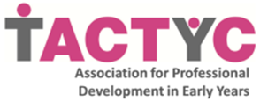

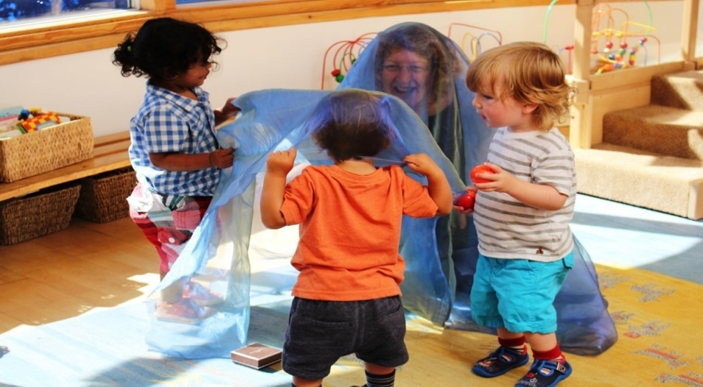
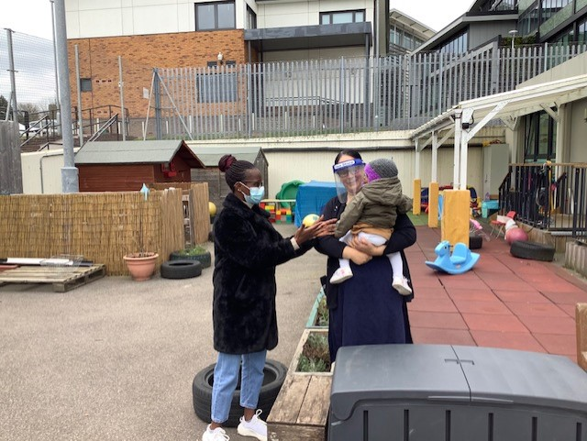
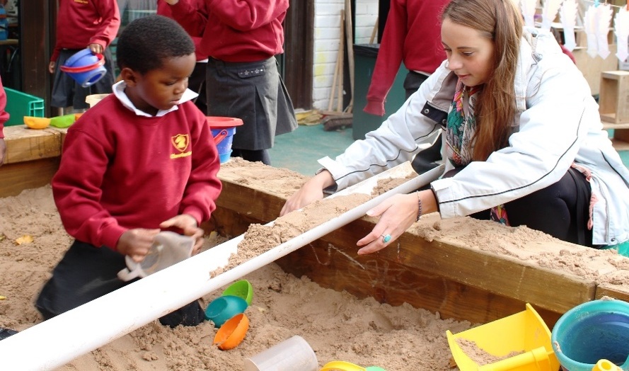

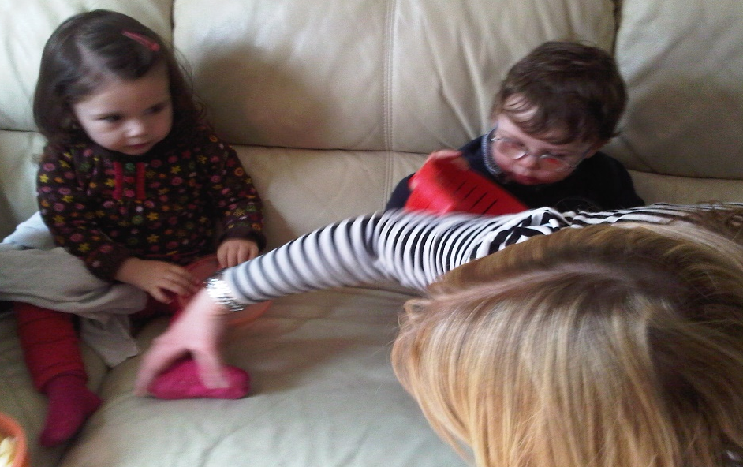

Children as leaders: Whose learning is it anyway?
Exploring 21st Century practice

How do we challenge traditional practice, thinking and routines to ‘flip the narrative?’

Saturday 11th June

Online Conference

Our 2022 one-day online conference brings together leaders, speakers and early childhood colleagues to dialogue about children as leaders and enablers of learning in the 21st Century: Where have we been, where are we now, and where are we going?

Children as leaders: Whose learning is it anyway?

TACTYC presents this special online conference for all those working in early childhood education and care, including practitioners, advisors, EYs leaders, advocates, students and academics. The TACTYC 2022 Conference will focus on ‘Children as knowledge holders and leaders of learning’. Delegates will gain fresh perspectives, critique existing positions and, will be able to create and contribute to dialogues on challenges and opportunities relating to children as leaders of learning in the 21st century

What did delegates say about our recent TACTYC Conferences?

‘Extremely beneficial and reinvigorating’ - ‘Many different professionals shared experiences and thoughts’ - ‘Really valuable’ - ‘A safe friendly environment to learn and reflect’ - ‘Totally refreshing’ - ‘Informative’ - ‘Space to think’ - ‘Provocative perspectives’ - ‘The chance to hear how the latest research can impact on my practice’ - ‘Fantastic’ – ‘Belonging’- ‘Didn’t think that the concept of transition was so dimensional’ – ‘it’s good to know I’m not the only one who want to make change’ – ‘making connections with other professionals is insightful’

The conference opens at 9:30am on Saturday 11th June, 2022 and closes at 12:30pm on Saturday 11th June, 2022. TACTYC’s AGM will also be held at the conference, from 12:00pm to 12:30pm, all members welcome.

2022 online Conference. How to register

The 2022 Conference is online and costs £30 for TACTYC members or £45 for non-members. There is still time to become a TACTYC member to access online webinars, dialogue and professional networking opportunity. To secure the most favourable conditions for debate and active participation, the number of delegates is limited to 100, on a first-come, first served basis. After registration, delegates will be provided with the address of the online conference and a password to access it.

Register for the 2022 TACTYC Conference (I will add link once set up)

Keynote presentation:
‘Children as leaders: Whose learning is it anyway?’
21st Century practice, advocacy and research

Key note speaker/s 1 bio and photo to add… (post agreement - will use info from link and ask speakers to write own bio – this is draft

Professor Claudio Baraldi and Professor Federico Farini present
Promoting young children’s agency in European schools. Facilitative pedagogical practices in Italy, Germany and England. Evidence from the CHILD-UP project.
Project over for TT

http://www.child-up.eu

http://www.child-up.eu/wp-content/uploads/2022/01/CHILD-UP-Save-the-Date-Final-Conference.pdf

Professor Farini profile: https://pure.northampton.ac.uk/en/persons/federico-farini

Professor Baraldi: http://personale.unimore.it/rubrica/dettaglio/cbaraldi

Key note speaker 2 bio and photo to add - Liz Chesworth
(post agreement - will use info from speaker for this section on flyer– this is draft only
Link to Liz profile- https://www.sheffield.ac.uk/education/people/academic/liz-chesworth

2022 online Conference. Membership opportunity

You do not need to be a member of TACTYC to join the conference but with the ongoing impact of Covid, many early years students, practitioners and professionals may be feeling more isolated than ever. To support our impactful early years community we invite those working with and for children to join us to discuss, network, research and publish in a community where advocacy is celebrated, embraced and expected.

Click here to join TACTYC today
Conference

Conference Programme

9.30-9.35 | House-keeping
9:35-9:45 | Welcome
9:45-10.15 | Keynote presentation 1: Professor Baraldi & Professor Farini share CHILD-UP European research project findings towards policy and practice impact and change  ‘
10:15-10.40 | Breakout Rooms and Discussion Forum  Dialogue between TACTYC Trustees, Delegates and Occasional Paper Presenters  Breakout Room (select one)  - Children as leaders, knowledge holders and enablers of learning  - Professionalism: How to manage the paradox of agency and accountability in practice  (iii) Working, writing and researching with real children, real futures, in real time
10:40-10.50 | Comfort Break
10.50-11.20 | Keynote presentation 2: Name Liz Chatsworth  Children as leaders: Whose learning is it anyway?  Challenging research, theory and traditional approaches in practice. Liz provokes reflective practice to critique models used to assess, listen and hear children’s expressions
11.20-11.40 | Discussion Forum – Group Feedback  Dialogue between speakers 1&2,  TACTYC Trustees & Delegates
11:40-11:50 | Students’ Award
11.50-12.00 | Closing Thoughts
12.00-12.30 | AGM

